SkillsUSA North Carolina
UAS Competition Agenda for Students and Teachers
April 15-16, 2026

Wednesday, April 15, 2026

2:00 pm – 5:00 pm (Room TBA)

Written Exam of 30 questions. The student shall provide an Airman Knowledge Testing Supplement Private Pilot (FAA-CT-8080-2G or FAA-CT-8080-2H)

Once the student has completed the 30 questions exam, they may proceed to the Judges room to be interviewed and debriefed on their Mission.

Mission Briefing (Room TBA)
The student will provide a written Mission Report and give the judges a briefing and post-briefing on the mission lasting no more than 5 minutes. This can be done by a laptop presentation or by using a hard copy for the following mission.

Search and Rescue Mission using a sUAS for missing adult last seen during

N34°46.59' W79°6.98'

He was last seen 48 hours ago.

Interview Room (Room TBA)
Student shall submit a resume to the Proctor upon his or her arrival in the testing room.
The candidate will be interviewed for a fictious drone pilot job.

Thursday, April 16, 2026

9:00 am – 5:00 pm (In front of the Field House)

Fly day using NIST skills test and obstacle course provided by NCDPI (Weather permitting) See below.
Pre-check and Post Check skills will be performed in front of the judge.
Note: Fly Day could be inside dependent on weather.

Contest Rules

• UAS SD card provided by the student.
- NIST Bucket Flights will be flown by the student pilot with no help from a Visual Observer (VO). The judge will act as a scribe writing down the numbers called out by the student. Each number represents points earned during the competition. See attached.
- The Obstacle flights will be flown by the student pilot with no help from a Visual Observer (VO). The judge will act as a scribe writing down missed obstacles during the flight by the student. Each obstacle missed will be points deductible during the competition. The course will be set up at random.
• In case of a tie, the flight times will be the deciding factor. Time starts when the UAS lifts off and returns touching the launching pad.
• Clothing requirement: Any Skills USA apparel will be accepted such as polo shirt (No school logo or sport hoodies), khaki pants and closed-toe shoes. In addition, the student will need to wear safety glasses, helmet, and a safety vest while operating the UAS.
• Clothing requirement: Any Skills USA apparel will be accepted such as polo shirt (No school logo or sport hoodies), khaki pants and closed-toe shoes. In addition, the student will need to wear safety glasses, helmet, and a safety vest while operating the UAS.
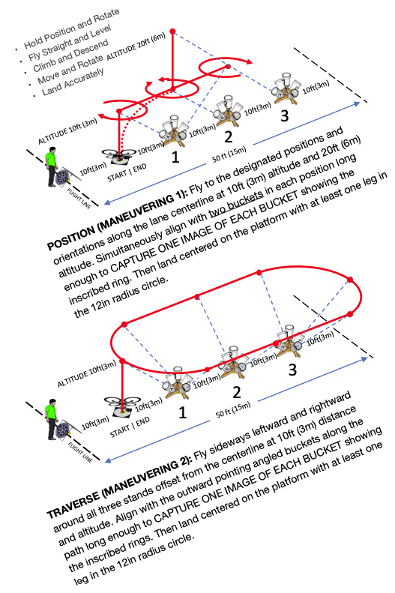

One of the following NIST props flight will be performed.

