Welcome to the 2024
SkillsUSA State Conference!

We are happy to announce this year’s membership –
over 12,750 members submitted! A new record!! This is a testament to your commitment and dedication to your skill development and training.

Special thanks go to our educational partners for their support of all Career & Technical Student Organizations, including State Superintendent Catherine Truitt; CTE Director Trey Michael; our Trade and Industrial Education Consultants Jim Pressly, Dr. David Barbour and Dr. Nolan Fahrer; and our partners at the NC Community College System Office: Dr. Bill Cox, President; Dr. Bob Witchger, CTE Director; and Dr. Tony Reggi, Associate CTE Director.

We also want to thank Middle Creek High School Digital Media Academy’s students and instructors for their planning and production of our ceremonies and audiovisuals.

We hope you all enjoy this year’s State Conference and we wish everyone the best of luck. Thank you for being such great Champions for SkillsUSA!

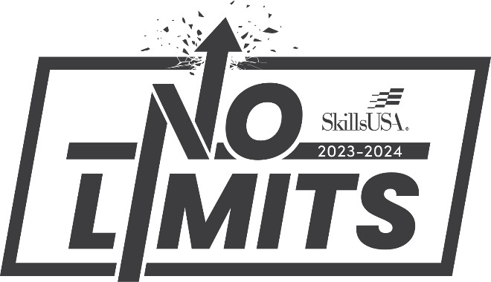
SkillsUSA North Carolina State Officers
Jacob Blackman High School President
Midway HS
Kayla Ingham Vice President
Pine Forest HS
Reece-Anna Cribb Secretary
South Columbus HS
Cameron Vaughan Treasurer
Lee County HS
Wesley Connor Reporter
South Columbus HS
Nathan Darnell Historian
Starmount HS
Ruth Hall Parliamentarian
West Carteret HS
Lexi Norwood Postsecondary President
Central Carolina CC

State Executive Committee
Paul Heidepriem Executive Director
Rod Lykins Dir. of Membership & Curriculum
Wil van der Meulen Postsecondary Support Director
Valerie Brewer State Leadership Coordinator

SkillsUSA North Carolina Board of Directors
Daryle Nobles, Chair Retired Educator
Tony Reggi NC Community College System
Dr. Nolan Fahrer NC Department of Public Instruction
Bill Burgess Carolina Training Associates
Kris Dell Applied Software
Carl Coffey Lowe’s Home Improvement
Ryan Shaver NC Masonry Contractors Association
Tim Eldridge Educational Services Unlimited
Judy Dinelle 84 Lumber
Liz Myhre Learning Labs
Barrett Crane Snap-on
Jeff Faircloth Guilford Technical Community College
Wayne Lee Retired Educator
Hardin Kennedy Retired Educator
Michael Williams Daimler
Jim Pressly (ex-officio) NC Dept. of Public Instruction
Dr. David Barbour (ex-officio) NC Dept. of Public Instruction
Dennis Marshall (PS AOY) Pitt Community College
Elaine Vallery (HS AOY) Retired
General Conference Information

Registration
Registration will be held Tuesday April 23 from 10:00am - 2:00pm at the Greensboro Coliseum. Chapter Advisors must pick up their chapter’s registration packets. Registration will be open for Postsecondary advisors only on April 23 from 6:30-7:00am at the Coliseum.

Conference Headquarters
The SkillsUSA North Carolina Conference Headquarters will be located at the Registration Desk at the Greensboro Coliseum and in the Heritage Room of the Koury Center. A staff person will be available at the Coliseum Tues. & Wed. from 7:30am – 4:00pm, and at the Koury Center Tues. from 4:00pm –10:00pm (except during the opening sessions) and Wed. from 8:00am – 9:00pm.

Hotel Check-In/Out
The chapter advisor must check-in/out, return keys, and pay for room bills. The hotel will provide a master bill for each delegation listing all charges. Check-in is 3:00pm and Check-out is 11:00am.

* Dress Code – Name Badges *
Conference name badges are part of the dress code and must be worn at all times. Official SkillsUSA dress, competition attire or business attire is required for both general sessions (polo shirts are allowed).
During awards sessions, winners will NOT be allowed on stage without official SkillsUSA dress, competition clothing or business like attire (except for AV personnel).

SkillsUSA North Carolina
Code of Conduct

The following rules and regulations will apply to ALL persons attending the SkillsUSA North Carolina State Leadership and Skills Conference. A good reputation enables you to take pride in your organization.
- Your behavior at all times should reflect credit to you, your school and your organization.
- Conference attendees must wear name badges at all times during the conference. Replacement name tags may be purchased at Headquarters for $10.00.
- Student conduct is the responsibility of the local SkillsUSA Advisor. SkillsUSA members are required to keep their advisor informed of their activities and whereabouts at all times.
- Everyone is expected to attend the general sessions. Please be prompt and courteous for sessions. Do not leave until sessions are adjourned. The dress code for general sessions is official SkillsUSA attire.
- No cell phones are allowed into competition.
- SkillsUSA members must report accidents, injuries or illness to their advisors immediately.
- If a student is guilty of theft or vandalism, the student and his/her parents will be expected to pay for the stolen or damaged item(s).
- Conference participants may not purchase, consume, or be under the influence of alcohol or drugs at any time.
- Students must follow the policies of their school and local Board of Education at all times.
- Students are expected to observe the designated curfew. Any student caught outside their room after curfew will be escorted to the security desk. Their advisor will be called to come to the desk.
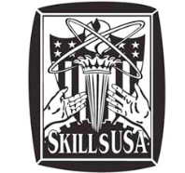
Violation of any of these rules may result in contacting your advisor and/or dismissal from the conference.

CONFERENCE SCHEDULE OF EVENTS
Check contest listings for specific times and locations for ALL contests
TUESDAY, April 23
8:00 am - 2:00 pm Skills Contest Setup
Greensboro Coliseum
10:00 am - 2:00 pm Conference Registration
Greensboro Coliseum-Foyer Registration Desk
10:00 am - 3:00 pm TechSpo & Exhibits
Greensboro Coliseum
10:00 am State Officer Candidate Screening
Greensboro Coliseum—Meeting Room 3
12:00 pm - 5:00 pm Skills Contest Orientations (HS)
** Refer to contest information below for specific times **
1:00 pm New Teacher Induction Training
Koury Center – Grandover
7:00 pm Opening Session
Koury Center - Guilford ABC
Following Opening Session HS Delegate Assembly
Koury Center - Guilford ABC
* Delegates must be in Official SkillsUSA or Business-like Attire

Following Opening Advisor Reception/Orientation
Koury Center - Guilford D
11:00 pm Curfew

WEDNESDAY, April 24
6:30 am Registration for Postsecondary Advisors
Greensboro Coliseum
7:00 am Chairpersons Report to Contest Locations
Greensboro Coliseum
7:30 am Skills Contestants report to contest site
Check contest listing for exact times and locations
8:00 am - 4:00 pm TechSpo & Exhibits
Greensboro Coliseum
8:30 am New Teacher Induction Training
Coliseum – Meeting Room 7

9:00 am Ribbon Cutting at Coliseum
Contest Viewing open for the Public
Following Ribbon Cutting Competition Floor Opens

7:00-10:00 pm Social/Fun Activity
@ Rockin’ Jump – 4215 W Gate City Blvd.
7:30 pm Postsecondary Awards
Koury Center - Guilford B

11:00 pm Curfew

THURSDAY, April 25
9:00 am Secondary Awards Ceremony *
Koury Center - Guilford Ballroom ABC

*Contestants MUST be in official dress, competition uniform or business-like attire to receive awards on stage (exception for AV personnel). Persons not in official dress may pick-up their award after the ceremony.

Immediately Following Awards……………
National Delegation Meeting – For all 1st place winners &
State Officers attending Nat’l Conference in Atlanta, GA
Guilford Ballroom Stage Area

Koury/Holiday Inn to Coliseum Shuttles

Tuesday: Noon - 5:00 pm
Wednesday: 6:45 am - 4:00 pm
Wednesday (to/from Rockin’ Jump): 7:00 - 10:00 pm
* Koury to Coliseum Shuttle Buses will pick up/drop off at the main entrance of the Koury Center and at the entrance of the Coliseum near the Fieldhouse, in 30 minute intervals.

OFF-SITE CONTESTS

Wednesday, April 24
Guilford Tech – CADM Bldg
6012 West Gate City Blvd., Greensboro, NC
Automotive Refinishing Collision Shop
Collision Repair Collision Shop
Collision Damage Appraisal Collision Shop
Welding High School Welding Lab
Guilford Tech – Jamestown
601 East Main St., Jamestown, NC
Advertising Design Gerald Hall 101
Shuttle Bus for All GTCC Contests above:
6:45 am: Depart Koury to GTCC
3:00 pm: Pick up at GTCC to Koury
Alamance CC
1375 Jimmie Kerr Road, Graham / Haw River, NC
Welding Postsecondary Welding Lab
Shuttle Bus: 6:30 am: Depart Koury to Alamance CC
4:30 pm: Pick up Alamance CC to Koury
Forsyth Tech
2100 Silas Creek Parkway, Winston Salem
Video News Production Broadcasting Lab
Shuttle Bus: 9:00 am: Depart Koury to Forsyth Tech
1:30 pm: Pick up Forsyth Tech to Koury
Johnson & Wales University
801 West Trade St., Charlotte, NC
Culinary Arts – High School
Baking & Pastry Arts – High School
Restaurant Service – High School
Shuttle Bus: 10:30 am: Depart Koury to JWU
5:00 pm: Pick up JWU to Koury
Phillips Corp
8500 Triad Drive, Colfax, NC
CNC - All CNC Competitions CNC Lab
No Shuttle

COMPETITIVE EVENTS

ORIENTATION NOTE:
- Orientations Identified on Tuesday are for High School & Middle School contestants only.

- Orientation will be held at contest location site unless otherwise indicated.

- If no Orientation date/time is listed, orientation will be conducted at the beginning of the contest.

3-D VISUALIZATION & ANIMATION
National Contest
Location: Greensboro Coliseum – Meeting Room 1
Event Date/Time: Wed. @ 8:00 am

ACTION SKILLS
State Contest
Location: Koury Center – Pinehurst
Event Date/Time: Wed. @ 1:00 pm

ADDITIVE MANUFACTURING
National Contest
Location: Greensboro Coliseum – Fieldhouse
Event Date/Time: (applies to HS & CPS)
Tues. 12:00 – 4:00 pm
Wed. 8:00 am – 12:00 noon

ADOBE VIDEO DESIGN
State Contest
Location: Greensboro Coliseum – Plaza, upper level
Event Date/Time: Wed. @ 8:00 am

ADOBE VISUAL DESIGN
State Contest
Location: Greensboro Coliseum – Plaza, upper level
Event Date/Time: Wed. @ 8:00 am

ADVERTISING DESIGN
National Contest
Location: Guilford Tech CC, Building – Gerrald Hall
609 East Main St.,Jamestown
Event Date/Time: Wed. @ 7:30 am

AMERICAN SPIRIT
National Contest
Location: Koury Center – St. Andrews
Event Date/Time: Wed. @ 9:00 am

ARCHITECTURAL DRAFTING
National Contest
Location: Greensboro Coliseum – Meeting Room 1
HS Orientation: Tues. @ 2:00 pm
Event Date/Time: Wed. @ 7:30 am

AUDIO/RADIO PRODUCTION
National Contest
Location: Greensboro Coliseum – Meeting Room 3
Event Date/Time: Wed. @ 8:00 am

AUTOMATED MAUNFACTURING TECHNOLOGY
National Contest
Event Date/Time: Held prior to April 24

AUTOMOTIVE REFINISHING TECHNOLOGY
National Contest
Location: Guilford Tech CC, CADM Building –
6012 West Gate City Blvd., Greensboro
Event Date/Time: Wed. @ 7:30 am

AUTOMOTIVE BEGINNER
State Contest
HS Orientation: Tues. @ 3:00 pm
Koury Center, Auditorium III
Contest Location: Greensboro Coliseum
Event Date/Time: Wed. @ 7:30 am
Advisor Debrief: Wed. @ 5:30 pm
Koury Center – Auditorium III

AUTOMOTIVE SERVICE TECHNOLOGY: MLR – CCP – PS
National Contest
Contest Location: Greensboro Coliseum
Event Date/Time: Wed. @ 7:30 am
Advisor Debrief: Wed. @ 5:30 pm
Koury Center – Auditorium III

AUTOMOTIVE / TRANSPORTATION
SKILL PROJECT SHOWCASE
State Contest
Location: Greensboro Coliseum – Automotive Area
Setup: HS – Tues. 12:00 pm – 3:00 pm
PS – Wed. 7:00 am – 8:30 am
Breakdown: Wed. @ 3:00 pm

AUTOMOTIVE TOOL ID
State Contest
Location: Greensboro Coliseum – Meeting Room 4
Event Date/Time: Wed. @ 8:00 am

AVIATION MAINTENANCE TECHNOLOGY
National Contest
Location: Greensboro Coliseum
Event Date/Time: Wed. @ 7:30 am

BAKING & Pastry Arts (High School)
National Contest
Location: Johnson & Wales University – 801 West Trade Street, Charlotte
Event Date/Time: Wed. @ 12:30pm

BAKING & Pastry Arts (Postsecondary)
National Contest
Event Date/Time: April 19 @ Carteret CC

BARBERING
National Contest
Location: Greensboro Coliseum
Event Date/Time: Wed. @ 7:30 am

BASIC HEALTH CARE SKILLS
National Contest
Location: Koury Center – Colony C
Event Date/Time: Wed. @ 10:30 am

CABINETMAKING
National Contest
Location: Greensboro Coliseum
HS Orientation: Tues. @ 2:00 pm – Meeting Room 4
Event Date/Time: Wed. @ 7:15 am

CABINETMAKING 1
National Contest
Location: Greensboro Coliseum
Event Date/Time: Tues. @ 1:00 pm

CABINTEMAKING
SKILL PROJECT SHOWCASE
State Contest
Location: Coliseum – Cabinetmaking Area
Setup: HS – Tues. 10:00 am – 2:00 pm
PS – Wed. 7:00 am – 8:30 am
Breakdown: Wed. @ 3:00 pm

CAREER PATHWAYS SHOWCASE
National Contest
Location: Greensboro Coliseum – Bridge, upper level
Setup: Tues. 10:00am–4:00pm, Wed. 7:00–8:30am
Event Date/Time: Wed. @ 9:00 am
Breakdown: Wed. @ 2:00 pm

CARPENTRY
National Contest
Location: Greensboro Coliseum
HS Orientation/Work: Tues. @ 1:00 pm – Mtg Rm 4
Event Date/Time: Wed. @ 7:30 am

CARPENTRY I
State Contest
Location: Greensboro Coliseum
HS Orientation: Tues. @ 1:00 pm – Meeting Room 4
Event Date/Time: Wed. @ 7:30 am
CARPENTRY
SKILL PROJECT SHOWCASE
State Contest
Location: Greensboro Coliseum – Carpentry Area
Setup: HS – Tues. 10:00 am – 2:00 pm
PS – Wed. 7:00 am – 8:30 am
Breakdown: Wed. @ 3:00 pm

CHAPTER DISPLAY
National Contest
Location: Koury Center – 3rd Floor Prefunction
Setup: High School: Tues. 10:00 am – 2:00 pm
Postsecondary: Wed. 7:00 am – 8:30 am
Event Date/Time: Wed. @ 10:00 am
Breakdown: Wed. @ 3:00 pm

CNC 2-AXIS TURNING SPECIALIST
National Contest
Location: Phillips Corp, 8500 Triad Drive, Colfax.
Event Date/Time: Wed. @ 7:30 am

CNC 3-AXIS MILLING SPECIALIST
National Contest
Location: Phillips Corp, 8500 Triad Drive, Colfax.
Event Date/Time: Wed. @ 7:30 am

CNC TECHNICIAN
National Contest
Location: Phillips Corp, 8500 Triad Drive, Colfax.
Event Date/Time: Wed. @ 7:30 am

COLLISION DAMAGE APPRAISAL
National Contest
Location: Guilford Tech CC, CADM Building –
6012 West Gate City Blvd., Greensboro
Event Date/Time: Wed. @ 7:30 am

COLLISION REPAIR TECHNOLOGY
National Contest
Location: Guilford Tech CC, CADM Building –
6012 West Gate City Blvd., Greensboro
Event Date/Time: Wed. @ 7:30 am

COMMUNITY ACTION PROJECT
National Contest
Location: Koury Center – St. Andrews
Event Date/Time: Wed. @ 9:00 am

COMMUNITY SERVICE
National Contest
Location: Koury Center – St. Andrews
Event Date/Time: Wed. @ 9:00 am

COMMUNITY EMERGENCY RESPONSE TEAM (CERT)
State Contest
Location: Greensboro Coliseum– Mtg Rm 8, upstairs
Event Date/Time: Wed. @ 8:30 am

COMPUTER PROGRAMMING
National Contest
Location: Greensboro Coliseum – Plaza, upper level
Event Date/Time: Wed. @ 8:00 am

CONSTRUCTION CORE
State Contest
Location: Greensboro Coliseum
Event Date/Time: Wed. @ 8:00 am

CONSTRUCTION ESTIMATING
State Contest
Location: Greensboro Coliseum – Meeting Room 4
Event Date/Time: Wed. @ 11:00 am

CONSTRUCTION TOOL ID
State Contest
Location: Greensboro Coliseum – Meeting Room 4
Event Date/Time: Wed. @ 9:00 am

COSMETOLOGY
National Contest
Location: Greensboro Coliseum
Event Date/Time: Wed. @ 7:30 am

COSMETOLOGY BEGINNER SKILLS
State Contest
Location: Greensboro Coliseum
Event Date/Time: Wed. @ 7:30 am

COSMETOLOGY
SKILL PROJECT SHOWCASE
State Contest
Location: Greensboro Coliseum – Cosmetology area
Setup: Tues. 10:00 am – 3:00 pm
Wed. 7:00 am – 9:00 am
Project Viewing: Tues. 2:00 pm - Wed. 3:00 pm
Breakdown: Wed. @ 3:00 pm

CREED
State Contest
Location: Koury Center – Pebble Beach
Event Date/Time: Wed. @ 12:00 noon

CRIME SCENE INVESTIGATION
National Contest
Location: Greensboro Coliseum – Fieldhouse
HS Orientation: Tues. @ 1:00 pm
Event Date/Time: Wed @ 7:30 am

CRIMINAL JUSTICE
National Contest
Location: Greensboro Coliseum – Fieldhouse
HS Orientation: Tues. @ 2:00 pm
Event Date/Time: Wed. @ 8:00 am

CULINARY ARTS (High School)
National Contest
Location: Johnson & Wales University – 801 West Trade Street, Charlotte
Event Date/Time: Wed. @ 12:30pm

CULINARY ARTS (Postsecondary)
National Contest
Event Date/Time: April 19 @ Carteret CC

CULINARY ARTS
SKILL PROJECT SHOWCASE
State Contest
Location: Koury Center – 3rd Floor Prefunction
Setup: Tues. 10:00am–4:00pm, Wed. 7:00–9:00am
Breakdown: Wed. @ 3:00 pm

CUSTOMER SERVICE
National Contest
Location: Koury Center – Augusta A/B
Event Date/Time: Wed. @ 8:30 am

CYBER SECURITY
National Contest
Location: Greensboro Coliseum – Plaza, upper level
Event Date/Time: Wed. @ 9:00 am

DEBATE
State Contest
Location: Koury Center – Biltmore A/B
Event Date/Time: Wed. @ 7:45 am

DENTAL ASSISTING
National Contest
Event Date/Time: April 18 @ Davidson Davie CC

DIESEL EQUIPMENT TECHNOLOGY
National Contest
Location: Greensboro Coliseum
Event Date/Time: Wed. @ 8:00 am

DIGITAL CINEMA PRODUCTION
National Contest
Location: Greensboro Coliseum – Meeting Room 3
Event Date/Time: Wed. @ 9:00 am

DIGITAL MEDIA
SKILL PROJECT SHOWCASE
State Contest
Location: Greensboro Coliseum – Bridge, upper level
Setup: Tues. 10:00am–4:00pm, Wed. 7:00–9:00am
Breakdown: Wed. @ 3:00 pm

DRAFTING I
State Contest
Location: Greensboro Coliseum – Meeting Room 1
HS Orientation: Tues. @ 2:00 pm
Event Date/Time: Wed. @ 8:30 am

DRONE PILOT
National Contest
Location: Greensboro Coliseum – Fieldhouse
Event Date/Time: (applies to HS & CPS)
Tues. @ 1:00pm – Meeting Rm 8
Wed. 8:00 am – Fieldhouse Outside

EARLY CHILDHOOD EDUCATION
National Contest
Location: Koury Center – Eastmoreland
Event Date/Time: Wed. @ 9:00 am

ELECTRICAL CONSTRUCTION WIRING
National Contest
Location: Greensboro Coliseum
HS Orientation: Tues. @ 2:00 pm - Meeting Room 3
Event Date/Time: Wed. @ 7:30 am

ELECTRICAL CONSTRUCTION WIRING 1
State Contest
Location: Greensboro Coliseum
HS Orientation: Tues. @ 3:00 pm - Meeting Room 4
Event Date/Time: Wed. @ 8:00 am

ELECTRONICS TECHNOLOGY
National Contest
Location: Greensboro Coliseum – Plaza, upper level
Event Date/Time: Wed. @ 8:00 am

EMERGENCY MANGEMENT POSTER
State Contest
Location: Greensboro Coliseum – Meeting Room 7
Event Date/Time: Wed. @ 10:30am

EMERGENCY MANGEMENT QUIZ BOWL
State Contest
Location: Greensboro Coliseum – Meeting Room 7
Event Date/Time: Wed. @ 1:00pm

EMPLOYMENT APPLICATION PROCESS
National Contest
Location: Koury Center – Sandpiper
Event Date/Time: Wed. @ 8:30 am

EMT
National Contest
Location: Greensboro Coliseum – Fieldhouse
Event Date/Time: Wed. @ 8:00 am

ENGINEERING TECHNOLOGY & DESIGN
National Contest
Location: Koury Center – 3rd Floor Prefunction
Setup: Tues. 10:00am–4:00pm, Wed. 7:00–9:30am
Event Date/Time: Wed. @ 10:00 am
Breakdown: Wed. @ 3:00 pm

ENGINEERING
SKILL PROJECT SHOWCASE
State Contest
Location: Greensboro Coliseum – Bridge, upper level
Setup: Tues. 10:00am–4:00pm, Wed. 7:00–9:00am
Breakdown: Wed. @ 3:00 pm

ENTREPRENEURSHIP
National Contest
Location: Koury Center – Bear Creek
Event Date/Time: Wed. @ 8:00 am

ESTHETICS
National Contest
Location: Greensboro Coliseum
Event Date/Time: Wed. @ 7:30 am

EXTEMPORANEOUS POSTER
State Contest
Location: Koury Center – 3rd Floor Prefunction
Event Date/Time: Wed. @ 9:00 am

EXTEMPORANEOUS SPEAKING
National Contest
Location: Koury Center – Links
Event Date/Time: Wed. @ 8:30 am

FANTASY HAIR AND MAKEUP
State Contest
Location: Greensboro Coliseum
Event Date/Time: Wed. @ 7:30 am

FIREFIGHTING (NATIONAL)
National Contest
Location: Greensboro Coliseum– Outside Fieldhouse
HS Orientation: Tues. @ 1:00 pm – Meeting Room 7
Event Date/Time: Tues.@ 1:45pm & Wed.@ 8:00am

FIREFIGHTING INTERMEDIATE
State Contest
Location: Greensboro Coliseum - outside Fieldhouse
HS Orientation: Tues. @ 1:00 pm – Meeting Room 7
Event Date/Time: Wed. @ 8:00 am

FIREFIGHTING BASIC
State Contest
Location: Greensboro Coliseum - outside Fieldhouse
HS Orientation: Tues. @ 1:00 pm – Meeting Room 7
Event Date/Time: Wed. @ 8:00 am

FIRST AID / CPR
National Contest
Location: Koury Center – Colony A
Event Date/Time: Wed. @ 8:00 am

GRAPHIC COMMUNICATIONS
National Contest
Event Date/Time: Held prior to April 24

HAIR COLORING
State Contest
Location: Greensboro Coliseum
Event Date/Time: Wed. @ 7:30 am

HEALTH KNOWLEDGE BOWL
National Contest
Location: Koury Center – Blue Ashe
Event Date/Time: Wed. @ 12:30 pm

HEALTH OCCUPATIONS PROFESSIONAL PORTFOLIO
National Contest
Location: Koury Center – Colony B
Event Date/Time: Wed. @ 11:00 am

HEATING, VENTILATION, AIR CONDITIONING AND REFRIGERATION
National Contest
Event Date/Time: April 12 @ Alamance CC

INDUSTRIAL MOTOR CONTROL
National Contest
Location: Greensboro Coliseum
Event Date/Time: Wed. @ 7:30 am

INFORMATION TECHNOLOGY SERVICES
National Contest
Location: Greensboro Coliseum – Plaza, upper level
Event Date/Time: Wed. @ 8:00 am

INTERACTIVE APPLICATION AND
VIDEO GAME CREATION
National Contest
Location: Greensboro Coliseum – Plaza, upper level
Event Date/Time: Wed. @ 8:30 am

INTERNET OF THINGS
National Contest
Event Date/Time: Held prior to April 24

INTERNETWORKING
National Contest
Location: Greensboro Coliseum – Lower Level
Event Date/Time: Wed. @ 8:00 am

JOB INTERVIEW
National Contest
Location: Koury Center – Sandpiper
Event Date/Time: Wed. @ 8:30 am

JOB SKILL DEMONSTRATION A
National Contest
Location: Koury Center – Blandwood
Event Date/Time: High School – Wed. @ 9:00 am
Postsecondary – Wed. @ 8:00 am

JOB SKILL DEMONSTRATION OPEN
National Contest
Location: Koury Center – Blandwood
Event Date/Time: High School – Tues. @ 1:00 pm
Middle School – Tues. @ 4:00 pm
Postsecondary – Wed. @ 8:00 am

MARINE SERVICE TECHNOLOGY
National Contest
Location: Greensboro Coliseum
Event Date/Time: Wed. @ 7:30 am

MASONRY
National Contest
Location: Greensboro Coliseum
Event Date/Time: Wed. @ 7:30 am
Masonry Banquet: Wed. @ 6:30 pm
The Khalif Event Center - 2000 E. Wendover Ave

MASONRY 1
State Contest
Location: Greensboro Coliseum
Event Date/Time: Wed. @ 8:30 am
Masonry Banquet: Wed. @ 6:30 pm
The Khalif Event Center - 2000 E. Wendover Ave

MASONRY BULLETIN BOARD
State Contest
Location: Greensboro Coliseum
Setup: Wed. @ 10:00 am – 12:30 pm
Event Date/Time: Wed. @ 1:00 pm
Breakdown: Wed. @ 3:00 pm
Masonry Banquet: Wed. @ 6:30 pm – Khalif Ctr

MASONRY ESTIMATING
State Contest
Location: Greensboro Coliseum – Meeting Room 4
Event Date/Time: Wed. @ 11:00 am
Masonry Banquet: Wed. @ 6:30 pm
The Khalif Event Center - 2000 E. Wendover Ave

MASONRY TOOL ID
State Contest
Location: Greensboro Coliseum – Meeting Room 4
Event Date/Time: Wed. @ 10:00 am
Masonry Banquet: Wed. @ 6:30 pm
The Khalif Event Center - 2000 E. Wendover Ave

MECHATRONICS
National Contest
Location: Greensboro Coliseum – Plaza, upper level
Event Date/Time: Wed. @ 8:00 am

MEDICAL ASSISTING
National Contest
Location: Koury Center – Colony C
Event Date/Time: Wed. @ 8:30 am

MEDICAL MATH
National Contest
Location: Koury Center – Auditorium III
Event Date/Time: Wed. @ 8:30 am

MEDICAL TERMINOLOGY
National Contest
Location: Koury Center – Auditorium II
Event Date/Time: Wed. @ 8:30 am

MEDICAL/HEALTH
SKILL PROJECT SHOWCASE
State Contest
Location: Greensboro Coliseum – Bridge, upper level
Setup: Tues. 10:00am–4:00pm, Wed. 7:00–9:00am
Breakdown: Wed. @ 3:00 pm

METALWORKING
SKILL PROJECT SHOWCASE
State Contest
Location: Greensboro Coliseum – Bridge, upper level
Setup: Tues. 10:00am–4:00pm, Wed. 7:00–8:30am
Breakdown: Wed. @ 3:00 pm

MIDDLE SCHOOL
SKILL PROJECT SHOWCASE
State Contest
Location: Greensboro Coliseum – Bridge, upper level
Setup: Tues. 10:00am–4:00pm, Wed. 7:00–9:00am
Breakdown: Wed. @ 3:00 pm

MOBILE ELECTRONICS INSTALLATION
National Contest
Event Date/Time: Held prior to April 24

MOBILE ROBOTICS
National Contest
Location: Greensboro Coliseum – Fieldhouse
HS Orientation: Tues. @ 2:00 pm
Event Date/Time: Wed. @ 8:00 am

MOTORCYCLE SERVICE TECHNOLOGY
National Contest
Location: Greensboro Coliseum
Event Date/Time: Wed. @ 7:30 am

NAIL CARE
National Contest
Location: Greensboro Coliseum
Event Date/Time: Wed. @ 7:30 am

NATURAL HAIR DESIGN & BRAIDS
State Contest
Location: Greensboro Coliseum
Event Date/Time: Wed. @ 7:30 am

NURSE ASSISTING
National Contest
Location: Koury Center – Colony B
Event Date/Time: Wed. @ 8:00 am
OPENING AND CLOSING CEREMONIES
National Contest
Location: Koury Center – Pebble Beach
Event Date/Time: Wed. @ 10:00 am

OUTSTANDING CHAPTER
National Contest
Location: Koury Center – St. Andrews
Event Date/Time: Wed. @ 9:30 am

PHOTOGRAPHY
National Contest
Location: Greensboro Coliseum – Plaza, upper level
Event Date/Time: Wed. @ 8:00 am

PIN DESIGN
National Contest
Display Setup: Koury Center – 3rd Floor Prefunction
Tues. 10:00 am – 2:00 pm (High/Middle School)
Wed. 7:00 am – 9:00 am (Postsecondary)
Interviews: High/Middle School – Tues. @ 2:30 pm
Postsecondary – Wed. @ 9:30 am

Breakdown: Wed. @ 2:00 pm

PLEDGE
State Contest
Location: Koury Center – Pebble Beach
Event Date/Time: Wed. @ 11:30 am

PLUMBING
National Contest
Event Date/Time: April 12 @ Alamance CC

POSTER
State Contest
Location: Koury Center – Prefunction Area 3rd Floor
Setup: Wed. 8:00 am – 11:30 am
Event Date/Time: Wed. Judging @ 12:00 noon
Remove Posters: Wed. @ 3:00 pm

POWER EQUIPMENT TECHNOLOGY
National Contest
Location: Greensboro Coliseum
Event Date/Time: Wed. @ 8:00 am
PRACTICAL NURSING
National Contest
Event Date/Time: Held prior to April 24

PREPARED SPEECH
National Contest
Location: Koury Center –Oyster Bay / Arrowhead B
Event Date/Time: Wed. @ 8:00 am

PRINCIPLES OF ENGINEERING
National Contest
Location: Koury Center – Bear Creek
Event Date/Time: Wed. @ 1:00 pm

PROMOTIONAL BULLETIN BOARD
National Contest
Location: Koury Center – 3rd Floor Prefunction
Setup: High School: Tues. 10:00 am – 2:00 pm
Postsecondary: Wed. 7:00 am – 8:30 am
Event Date/Time: Wed. @ 8:30 am
Project Viewing: Tues. 2:00 pm - Wed. 3:00 pm
Breakdown: Wed. @ 3:00 pm

QUIZ BOWL
National Contest
Location: Koury Center – Blue Ashe
Event Date/Time: Wed. @ 8:00 am

RELATED TECHNICAL MATH
National Contest
Location: Koury Center – Auditorium III
Event Date/Time: Wed. @ 8:30 am

RESIDENTIAL COMMERCIAL AND APPLIANCE TECHNOLOGY
National Contest
Event Date/Time: April 12 & Alamance CC

RESTAURANT SERVICE (High School)
National Contest
Location: Johnson & Wales University – 801 West Trade Street, Charlotte
Event Date/Time: Wed. @ 12:30pm

RESTAURANT SERVICE (Postsecondary)
National Contest
Event Date/Time: April 19 @ Carteret CC

ROBOTICS AND AUTOMATION
National Contest
Event Date/Time: Held prior to April 24

ROBOTICS: URBAN SEARCH & RESCUE
National Contest
Location: Greensboro Coliseum – Fieldhouse
Notebook Submission: Tues. before 12:00 noon,
Registration Desk or Fieldhouse
Event Date/Time: Wed. @ 7:00 am

SCREEN PRINTING
National Contest
Event Date/Time: Held prior to April 24

SHEET METAL
National Contest
Event Date/Time: April 12 @ Alamance CC

SKILL PROJECT SHOWCASE
State Contest
Event Date/Time/Location: See above alphabetically by Showcase Category/Area

SPELLING
State Contest
Location: Koury Center – Auditorium III
Event Date/Time: Wed. @ 8:30 am

T-SHIRT DESIGN
National Contest

Display Setup: Koury Center – 3rd Floor Prefunction
Tues. 10:00 am – 12:30 pm (High/Middle School)
Wed. 7:00 am – 8:30 am (Postsecondary)
Interviews: High School – Tues. @ 1:00 pm
Middle School – Tues. @ 2:00 pm
Postsecondary – Wed. @ 9:00 am

Breakdown: Wed. @ 2:00 pm

TEAM ENGINEERING CHALLENGE
National Contest
Location: Greensboro Coliseum – Fieldhouse
Event Date/Time: Wed. @ 8:00 am

TEAMWORKS
National Contest
Location: Greensboro Coliseum
Event Date/Time: Tues. 1:00 pm & Wed. 8:00 am

TECHNICAL COMPUTER APPLICATIONS
National Contest
Location: Greensboro Coliseum – Plaza, upper level
Event Date/Time: Wed. @ 8:00 am

TECHNICAL DRAFTING
National Contest
Location: Greensboro Coliseum – Meeting Room 1
HS Orientation: Tues. @ 2:00 pm
Event Date/Time: Wed. @ 7:30 am

TELECOMMUNICATIONS CABLING
National Contest
Location: Greensboro Coliseum – Lower Level
Event Date/Time: Wed. @ 8:30 am

TELEVISION (VIDEO) PRODUCTION
National Contest
Location: Greensboro Coliseum – Meeting Room 3
Event Date/Time: Wed. @ 8:00 am

VIDEO NEWS PRODUCTION
National Contest
Location: Forsyth Tech CC
Event Date/Time: Wed. @ 10:00 am

WEB DESIGN
National Contest
Location: Greensboro Coliseum – Plaza, upper level
Event Date/Time: Wed. @ 8:00 am

WEDDING CAKE DECORATING (H.S.)
State Contest
Location: Koury Center – 3rd Floor Prefunction
Event Date/Time: Wed. @ 9:00 am

WEDDING CAKE DECORATING (Postsec)
State Contest
Event Date/Time: April 19 @ Carteret CC

WELDING (High School)
National Contest
Location: Guilford Tech CC, CADM Building –
6012 West Gate City Blvd., Greensboro
Event Date/Time: Wed. @ 8:00 am

WELDING (Postsecondary)
National Contest
Location: Alamance CC – AATC Building
1375 Jimmie Kerr Road, Graham
Event Date/Time: Wed. @ 7:30 am

WELDING FABRICATION
National Contest
Location: Greensboro Coliseum – Plaza, upper level
Setup: Wed. 7:00 am – 7:30 am
Event Date/Time: Wed. @ 9:00 am

WELDING SCULPTURE
National Contest
Location: Greensboro Coliseum – Bridge, upper level
Setup: Tues. 10:00am–4:00pm, Wed. 7:00–8:30am
Event Date/Time: Wed. @ 9:00 am
Breakdown: Wed. @ 3:00 pm
________________________
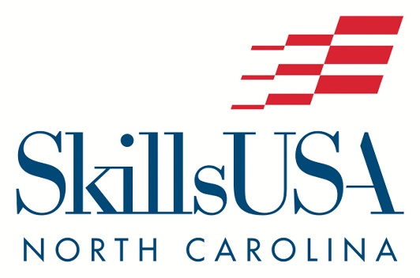

CHAPTERS OF DISTINCTION

Avery County High School
Carrboro High School
Carteret Community College
Catawba Valley Community College
East Davidson High School
Jack Britt High School
Midway High School
Nash Community College
North Iredell High School
Roanoke Rapids High School
West Carteret High School
West Stanly High School

QUALITY CHAPTERS

A L Brown High School
Bear Grass Charter School
Hickory Ridge High School
Kannapolis Middle School
Lee County High School
Mattamuskeet School
Mooresville High School
Pamlico County High School
Pamlico County Middle School
Pender High School
Pine Forest High School
Richlands High School
South Columbus High School
South Iredell High School
South Stanly High School
Pitt Community College
Winston Salem Forsyth Career Center

UPCOMING EVENTS

National Skills & Leadership Conference
June 24-29, 2024 – Atlanta, GA

State Leadership Workshop At Camp Dixie
Sept. 29 – Oct. 1, 2024 – Fayettville, NC

2025 State Leadership & Skills Conference
April 9-11, 2025 – Greensboro, NC

SkillsUSA Framework
SkillsUSA has an impact on the lives of America’s future workforce through the development of personal, workplace and technical skills that are grounded in academics.
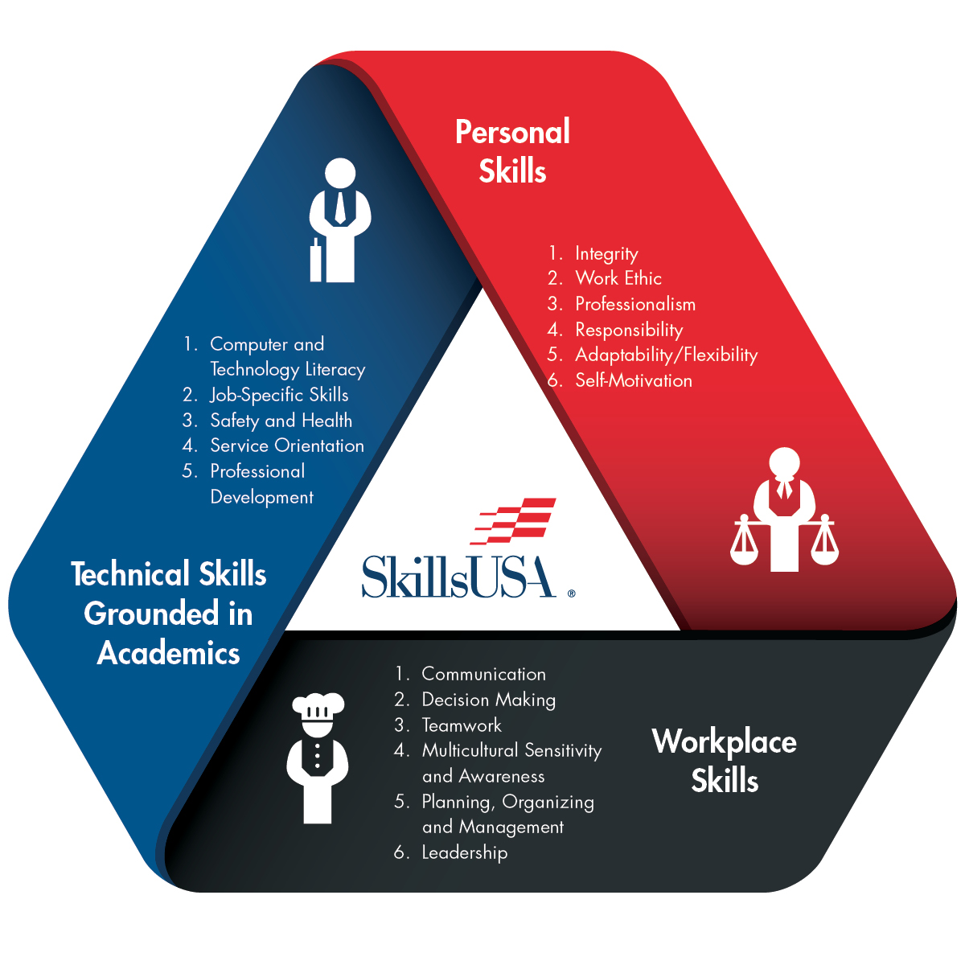

Developed based on input from industry, the SkillsUSA Framework delivers a skill set that is demanded by business and industry.

Visit SkillsUSA.org to download the Framework graphic and start empowering students today.
NOTES
___________________________________________

___________________________________________

___________________________________________

___________________________________________

___________________________________________

___________________________________________

___________________________________________

___________________________________________

___________________________________________

___________________________________________

___________________________________________

___________________________________________

___________________________________________

___________________________________________

___________________________________________

___________________________________________

___________________________________________

___________________________________________

___________________________________________

