Restaurant Service Addendum 2024

Clothing Requirement
- White long-sleeved dress shirt (with or without SkillsUSA logo)
- Black dress slacks with belt, or skirt (knee-length minimum)
- Plain black tie with no pattern or SkillsUSA black tie
- Shined non-skid black leather work shoes or black flat heels
- Non-bib Bistro aprons are the official apron for Food & Beverage Service and are required.
- Note: Wearing socks or hose is no longer required. If worn, socks must be black dress socks and hose must be either black or skin-tone and seamless/nonpattern.
- Note: Waiter’s jackets, bow ties, vests, cummerbunds or half aprons are not permitted.

Clothing Items do not have to have the official SkillsUSA logo for NC Competition, but must otherwise match the descriptions above.

Equipment and Materials List
Supplied by the Technical Committee
- All equipment
- All “food” and beverages (except for optional items next column)
- Flatware, trays, table settings, cloths, napkins
- Tax charts
- Guest checks and check presentation folders
- Menus and description of the daily chef’s featured dishes

Supplied by the Contestant
- Wine key (for Postsecondary)
- One ink pen (blue or black)
- No. 2 pencil for written test

Cell phones or other electronic devices are NOT allowed in the competition area.

Scope of Contest
- Table Set Up based on menu
- Menu Presentation to Guests
- College / Postsecondary -- Wine Service
- High School -- Juice Drink (Mock tail – layer, garnish, etc.) Service for Two
- Napkin presentation (Bishop Hat, Candlestick, and 1 of contestant’s choice)

See national technical standards for more details on contest scope. SkillsUSA North Carolina reserves the right to make adaptations or changes based on time, materials, and facility requirements.

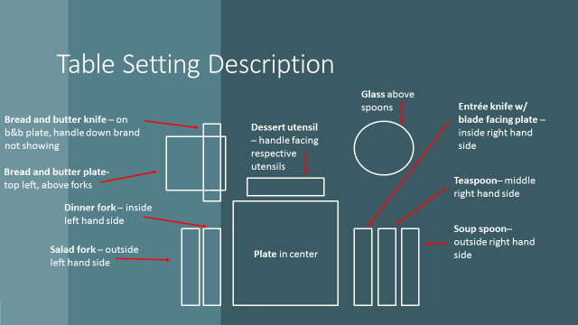

BISHOPS HAT Examples

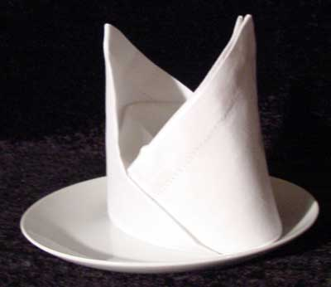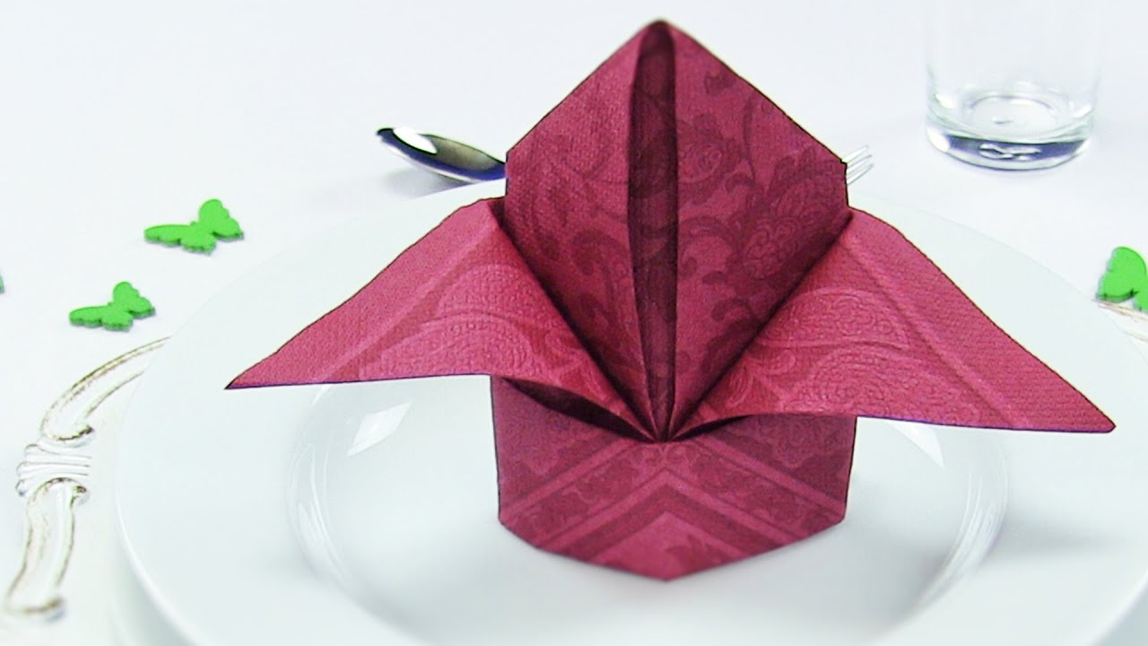

Appetizer
choose one appetizer

New England Clam Chowder
chopped clams bacon, onions,
and potatoes in a thick creamy clam stock

Spinach Salad
tender baby spinach leaves with mushrooms, egg, and bacon served with red wine vinaigrette

Entrées
choose one entree
entrees served with sautéed whole green beans with almonds and potato pancakes

Grilled Marinated Salmon with Maple Glaze
salmon fillet marinated with light herbs, grilled and
glazed with maple syrup

Smoke-Roasted Spiced Chicken Breast
with Fruit Salsa
smoked boneless chicken breast seasoned with cumin, paprika,

coriander, and thyme served with fruit salsa

Dessert
choose one dessert

Apple Pie alamode

White Chocolate Mousse Cake

All meals include bakery fresh breads, butter, coffee,
decaffeinated coffee, iced tea or water.

