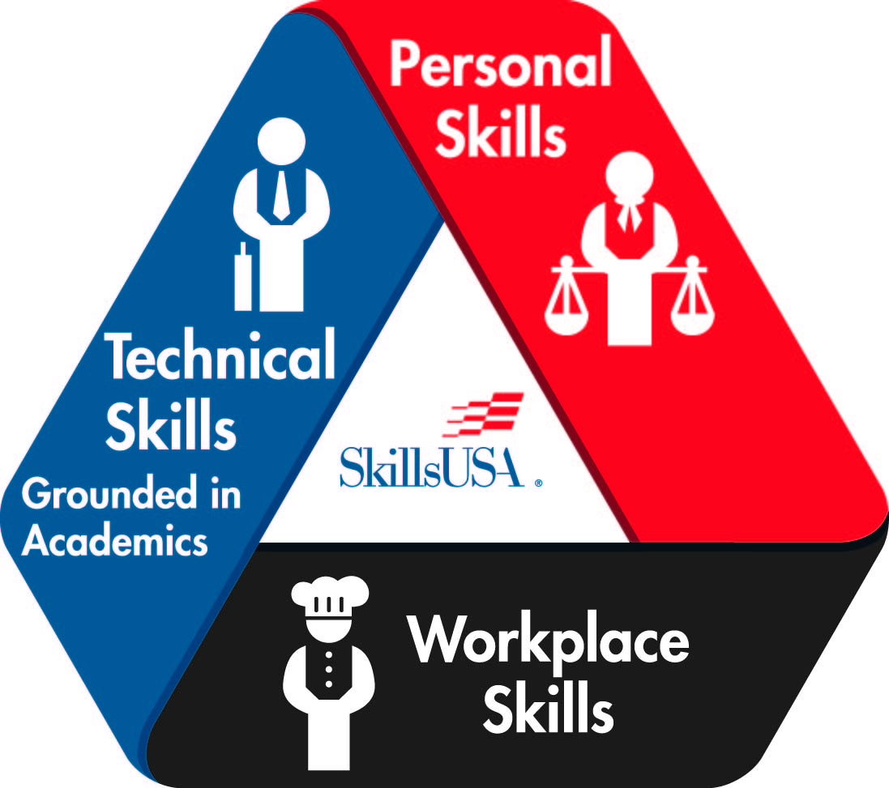
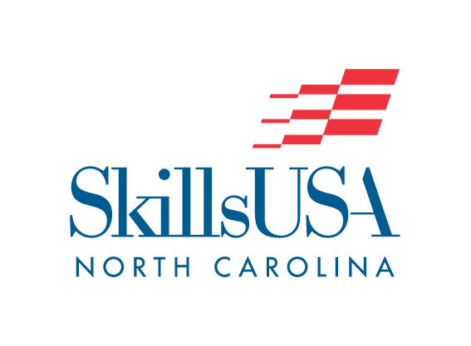
SkillsUSA NORTH CAROLINA
POSTER CONTEST
(REGIONAL/STATE-ONLY CONTEST)

PURPOSE

Evaluate the contestant’s ability to develop and prepare a SkillsUSA promotional poster and present the content to the judges.

CLOTHING REQUIREMENTS

Business casual dress.

ELIGIBILITY

1. Open to active SkillsUSA members enrolled in Public Safety Academy courses.

EQUIPMENT AND MATERIALS

- Supplied by SkillsUSA:
- Five copies of regulations.
- One copy of form to report results.
- Tables.
- Pencils.
- One room.

- Supplied by The Host:
- One chairperson.
- Three judges.

SCOPE OF THE CONTEST

- The theme for the poster will be the student’s choice:
a. Create a public education campaign for residents of your county about flood preparedness, response, and recovery.
b. Research what causes flooding, what areas of your county are most prone to flooding, and what can be done to mitigate flooding in your community.

- The poster shall be designed and constructed by one Skills member only.

- Only students will be allowed to set up the posters according to instructions given by the contest chairperson or the conference program.
- Failure to comply with any requirement listed above will result in a penalty for each rule violation.

Scoring

Educational Information Value – 200 pts
Layout and Design – 200 pts
Workmanship – 200 pts
Creativity and Originality – 200 pts
Current Theme Displayed on Poster – 100 pts
Poster Relates to the Current Theme – 100 pts

