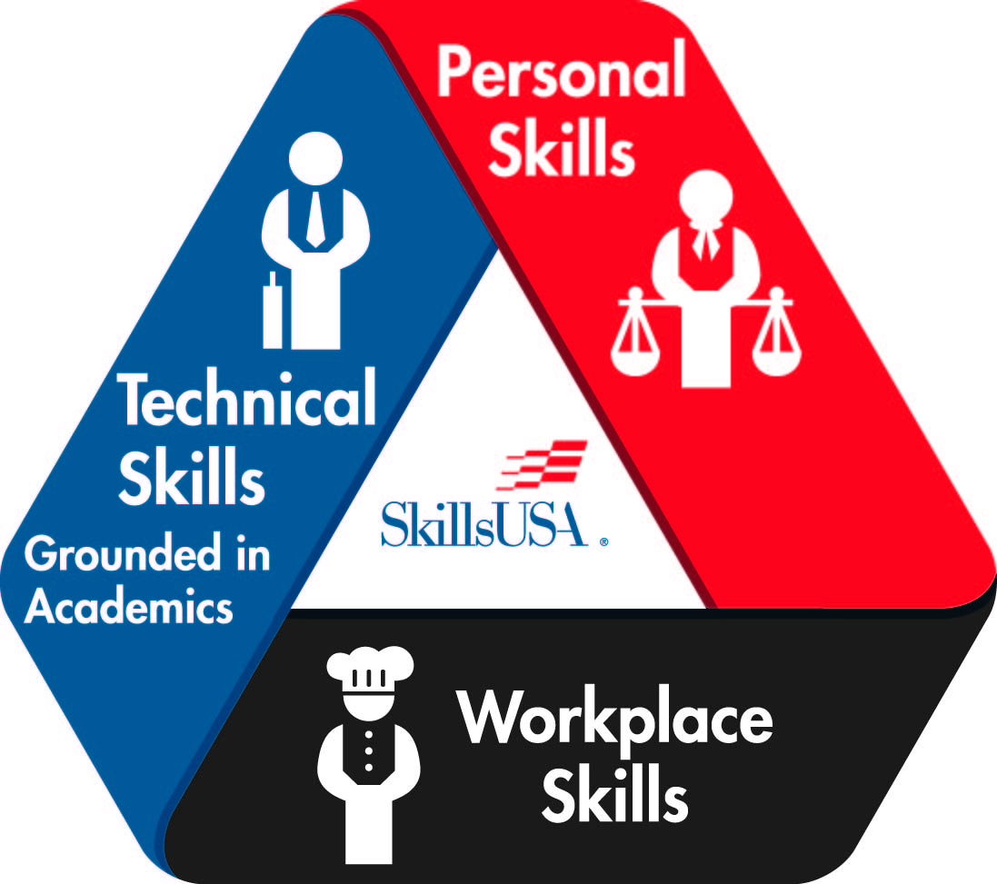
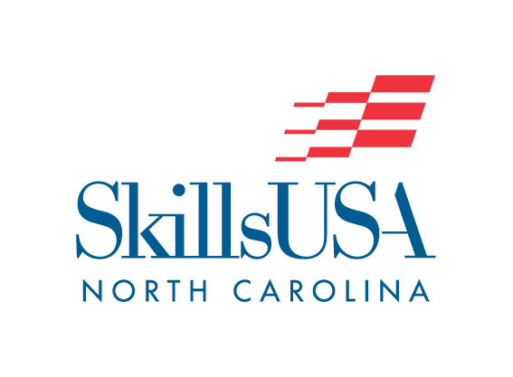
EMERGENCY MANAGEMENT
POSTER CONTEST
(REGIONAL/STATE-ONLY CONTEST)

PURPOSE

Evaluate the contestant’s ability to develop and prepare an Emergency Management promotional poster.

CLOTHING REQUIREMENTS

Official SkillsUSA blazer or windbreaker, white dress shirt and black tie or white blouse, black dress pants or skirt, black dress shoes (closed toe).

ELIGIBILITY

1. Open to active SkillsUSA members enrolled in Emergency Management Program courses.

EQUIPMENT AND MATERIALS

- Supplied by SkillsUSA:
- Copies of regulations.
- Scorecard/Results sheet.
- Tables.

- Supplied by The Host:
- One chairperson.
- Three judges.

SCOPE OF THE CONTEST

- The theme for the poster will be the current National SkillsUSA theme/subtheme and must be stated on the poster.

- The poster shall be designed and constructed by one SkillsUSA member only.

- Entries shall be constructed on 22” x 28” poster board.

- Only students will be allowed to set up the posters according to instructions given by the contest chairperson or the conference program.

- Failure to comply with any requirement listed above will result in a penalty for each rule violation.

Scoring

Educational Information Value – 200 pts
Layout and Design – 200 pts
Workmanship – 200 pts
Creativity and Originality – 200 pts
Current Theme Displayed on Poster – 50 pts
Poster Relates to an Emergency Management Subject or Theme – 50 pts
Oral Presentation Component - 100

Resume Penalty – minus 10 pts
Clothing Penalty – 0 to -10 pts

