Culinary Arts Addendum 2023 High School

Clothing Requirement
- Black work pants or black-and-white checkered chef’s pants
- White chef’s jacket (if it has a school logo or sponsor logo, the logo must be covered completely)
- Black non-slip, non-porous shoes
- White apron
- Hair Restraint as needed.
- White Chef’s hat (toque) or skull cap
- White neckerchief (optional)
- Side-towels, Chef’s hats (toques) or skull caps (no baseball caps).

Clothing items do not have to have the SkillsUSA logo but must otherwise match the descriptions above.

No facial jewelry is allowed. Earrings are not permitted even if covered by a bandage. A single watch or wedding ring is the only jewelry that will be allowed to be worn during the orientation periods. All hair must be restrained and off the collar – this may require a hat and hairnet. Beards must be covered by a snood during all periods of food handling.

Cell phones or other electronic devices are NOT allowed in the competition area.

NEW THIS YEAR, Aligning with the National contest standards:
  - All competitors must submit a copy of a current ANSI approved food safety manager or food handler certification at orientation. Failure to do so will result in a 10-point penalty. This is required for ALL national contestants at both HS & PS level.
HS exemption for NC state competition only – NC will allow for advisor/instructor verification that student-contestant is qualified for food safety.
  - All competitors must create a menu of what they will produce and submit four copies at the beginning of their competition day.

Tool List Note
No additional equipment beyond what is listed in the national technical standards is allowed to be used in the contest. Contestants will not be allowed to share tools or equipment.

No knife cut measuring devices can be used.

Event will take place at Piedmont Food Processing Center.
There is no room for any spectators.

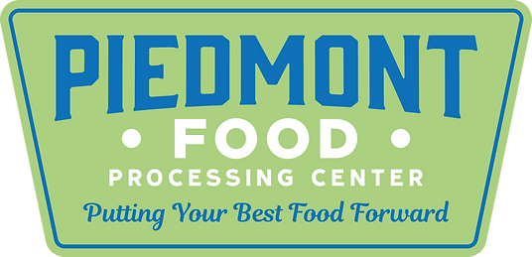

Scope of Contest
- Time - Students will have 2.5 hours to make 3 knife cuts, fabricate a chicken, prepare a soup and an entrée’.

- Knife Cuts
  - These 3 knife cuts must be utilized in the finished product.
    - Minced onions, julienne carrots, medium diced potato

- Fabricate a Chicken
- High School: Two breasts – The breast should be skin on and boneless, except for the first bone of the wing which should be attached. The tender should be intact and attached to the breast. The wing bone and tender can be removed after evaluation for use in the menu as desired.
- Prepare a Soup –
High School - CREAM SOUP – use vegetable knife cuts in soup.

  - Chicken or Beef Base
- Skill component: Base/Cream Soup Yield: 2 servings
- Ingredients:
- Vegetables
- Cream
- Seasoning
- Garnish

- Entrée
  - High School – Students will prepare a sautéed chicken with sauce entrée, starch, and vegetable.

See national technical standards for more details on contest scope. SkillsUSA NC reserves the right to make adaptations or changes based on time, materials, and facility requirements.

SkillsUSA
Culinary Arts
Student-Provided Equipment  MANDATORY EQUIPMENT  Students will not be allowed to compete without this minimum level of equipment. | Site-Provided Equipment
- Sautee Pans -2  - Sauce Pots -2  - Stock Pots -2  - Hotel Pans -3  - Cutting Boards -2  - Tongs -3  - Spatulas -3  - Large Spoons -3  - Strainers/Chinois -1  - Measuring Cups/Spoons  - Knife Kit  - Chef’s Knife  - Paring Knife  - Boning Knife  - Slicing Knife  - Knife Steel  - Vegetable Peeler  - Thermometer  - Side Towels  - Cleaning Towels | - Sheet Pans  - Plastic Wrap  - Tin Foil  - Cheesecloth  - Twine  - Disposable Gloves  - Tape (for labeling)  - Display Bowls/Plates  OPTIONAL- Student Provided  - Any approved equipment from the national technical standards tool list – may be shared with all students competing.

Common Kitchen Items for High School Only

Dry Goods  • AP Flour  • Sugar  • Corn Meal  • Corn starch  • Brown rice  • Lentils  • Bread  • Honey  • Vegetable oil  • Extra virgin olive oil  • Soy sauce  • Tabasco  • Dijon mustard  • Almonds  • Tomato puree  • White wine vinegar  • Red wine vinegar  • Assorted dry spices.  • Chicken base  • Beef base  • Red wine (cooking wine)  • White wine (cooking wine) | Produce  • Apples  • Lemons  • Garlic  • Onions  • Scallions  • Carrots  • Celery  • Red Peppers  • Mushrooms  • Spinach  • Parsley  • Potatoes  • Tomatoes | Dairy  • Butter  • Cream  • Milk  • Eggs  • Cheddar Cheese  • Parmesan Cheese  Protein  1 - 3 lb. Chicken per student

