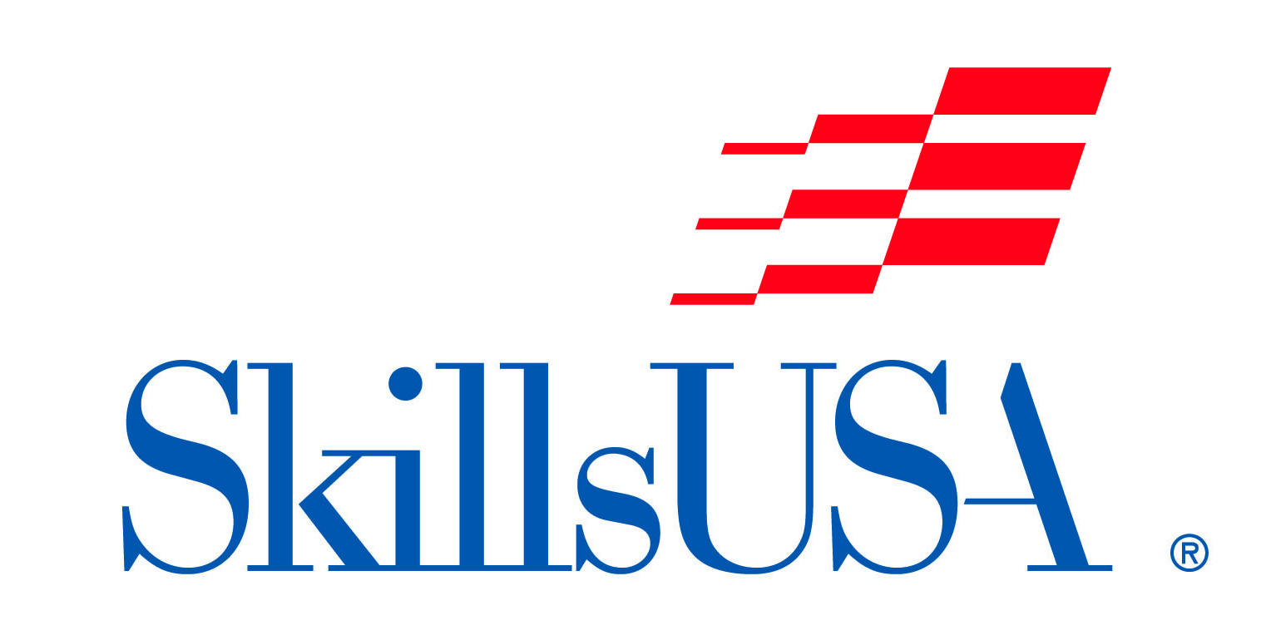**“FANTASY NAIL ART DESIGN”**

**Manikin Hand Competition**

**(Showcase Design – Completed-In-Advance)**

**2025 Theme: UNDER THE SEA**

*The “Fantasy Nail Art Design” Manikin Hand Competition is open to all NC Cosmetology students. SkillsUSA membership is not required to compete.*

**Contest Information:**

This is a manikin hand showcase competition, where all nail art design has been completed PRIOR TO competition day, and the completed manikin hand is brought to the competition site for showcasing and judging.

2 pages need to accompany the completed manikin –

1. Written Description of your nail design theme (see above Theme) and the complete process (techniques) use to achieve it.
2. Photos – 1 page of photos showing process of progress (example – manikin hand before the Fantasy Nail Design, 1 or more photos of the Fantasy Nail Design process.

A table space will be provided for you to display your manikin hand as well as your description and photo. The only items you will need to provide is a completed manikin hand and 2 pages (identified above).

**Display space allowance will be 2.5’ wide by 1.5’ deep.**

**Contestants/Advisors are required to construct and bring support(s) for or within your display**, to prevent wind and outdoor elements from compromising or destroying them while on display at the contest site.

Manikin Hand: student’s Choice

Manikin Hands will be judged in the following categories:

1. Creativity
2. Originality
3. Execution
4. Adaptability
5. Design keeping with the given Theme (yes/no)
6. Total Look

SHOW YOUR CREATIVITY!!!

**Tentative Schedule:**

8:30 AM – 9:30 AM Competitor/ Manikin Hand check-in & Set-up

10:00 AM – 12:00 PM Judging

1:30 PM – 1:45 PM Presentation Parade (if contestant is present)

1:45 PM – 2:00 PM Announcement of Winners

Please allow all manikin hands to remain on exhibit until all competitions end at 2:00 PM.

All decisions of the judges are final.

*For additional information please contact:*

Morris “Boz” Boswell - Competition Chairperson

[mbos324556@aol.com](mailto:mbos324556@aol.com) or (336) 214-3730

or SkillsUSA-NC – 919-675-1241 or [info@SkillsUSAnc.org](mailto:info@SkillsUSAnc.org)