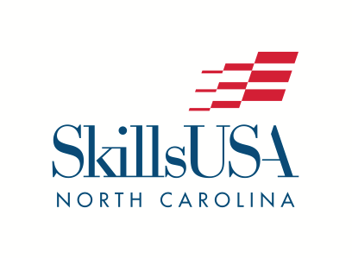
2025 NLSC PRESS RELEASE

P.O. Box 88
Oxford, NC 27565
Phone: (919) 675-1241
info@SkillsUSAnc.org
www.SkillsUSAnc.org

FOR IMMEDIATE RELEASE

July 1, 2025:
303 North Carolina Career & Technical Education students from 38 high schools, 4 middle schools and 29 community colleges participated in the 60th annual SkillsUSA National Leadership and Skills Conference in Atlanta June 23-27, 2025. The North Carolina Delegation consisted of over 550 students, teachers, parents, administrators and competition team members.

North Carolina was very well represented in the SkillsUSA Championships, earning a total of 78 medallions (2nd highest in the nation!). Students earned 14 gold, 40 silver, and 24 bronze medals.

28% of our student-contestants were medalists. 61% placed in the top 10 in their contests.
The Postsecondary delegation consisted of 50 medalists (42% of the Postsecondary delegation of 120) and 105 placed in the top 10 (88%).
The High School delegation consisted of 15 medalists (12% of the High School delegation of 131) and 38 placed in the top 10 (29%).
The Middle School delegation consisted of 13 medalists (41% of the Middle School delegation of 32) and 28 placed in the top 10 (88%).

Student members competed at the state level, the SkillsUSA North Carolina State Conference in April. Each student-member competing had to place first in their respective competition at the state level in order to qualify to compete at the national level.

Eight SkillsUSA North Carolina State Officers engaged in the LEVERAGE State Officer Training at the National Conference and served as voting delegates for the SkillsUSA national officer team elections.

In addition to excellence in competitive events, North Carolina was honored to have Carteret Community College selected as 1 of 24 national Models of Excellence, a distinction given to the top 24 chapters in the country.

Christian Spell from Midway High School was elected as the SkillsUSA National Region 2 Vice President for the 2025-26 year.

North Carolina was also recognized for having the Region 2 Finalist for SkillsUSA Advisor of the Year – Wanda Tyson from Nash Community College. We are extremely honored to have Mrs. Tyson recognized as one of the top 5 SkillsUSA Advisors in the nation!

SkillsUSA North Carolina also received an award for increase in membership for the high school division.

“We are incredibly proud of our students and teachers for embodying our slogan of being ‘Champions at work’”, said Paul Heidepriem, SkillsUSA North Carolina Executive Director. “Our teachers and instructors are ensuring that the Framework of Personal, Workplace & Technical Skills are developed in each classroom.”

SkillsUSA is a nonprofit partnership of education and industry founded in 1965 as Vocational Industrial Clubs of America (V.I.C.A.) to strengthen our nation’s skilled workforce. Driven by employer demand, SkillsUSA helps students develop necessary personal and workplace skills along with technical skills grounded in academics. This SkillsUSA Framework empowers every student to succeed at work and in life, while helping to close the skills gap in which millions of positions go unfilled. Through SkillsUSA’s championships program and curricula, employers have ensured schools are teaching relevant technical skills, and with SkillsUSA’s new credentialing process, they can now assess how ready potential employees are for the job. SkillsUSA has hundreds of thousands of members nationwide in high schools, middle schools and colleges, covering over 140 trade, technical and skilled service occupations, and is recognized by the U.S. Departments of Education and Labor as integral to career and technical education. With the addition of our alumni, membership last year was over 440,000. SkillsUSA receives in-kind and financial support from more than 650 national partners. SkillsUSA has served more than 14 million members since 1965. For more information, go to SkillsUSA.org and SkillsUSAnc.org .

