2022-23 SkillsUSA Championships

Regional Contest Project

Additive Manufacturing

Kinematic Assembly Models

Welcome to the “Kinematic Assembly Models” challenge!

The task at hand is to design a functional/movable assembly, also known as a gear system, or kinematic model.

Examples of this type if system are below, this should help get you started on an idea:
- Peristaltic Pump
- Geneva Gear
- Rack and Pinion
- Differential
- Planetary Gear
- Bearing

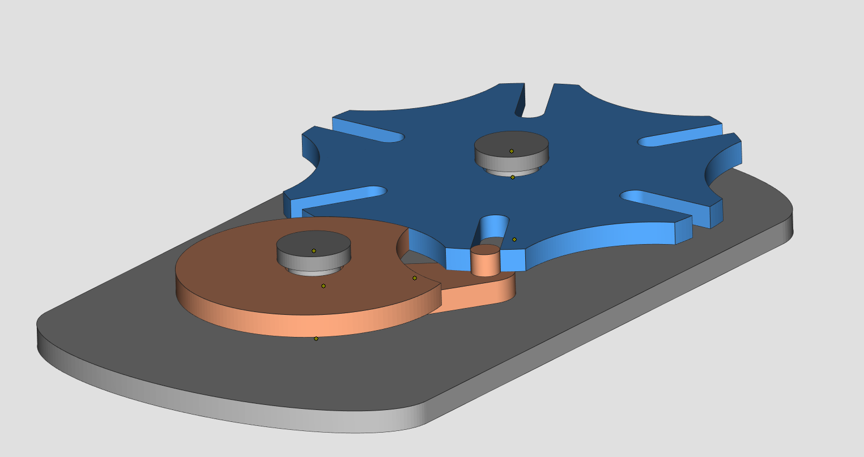
Example of a functional assembly for reference only

Competition Requirements

- The design must contain at least 3 individual bodies to be printed assembled or to be assembled after printing.
- Printed parts must be able to mate and stay together during operation by design or additional hardware provided by contestant.
- The design must contain at least two printed moving parts in the assembly.
- One printed part’s motion must be directly driven by another printed parts motion.
- The printed parts must be able to mate together as an assembly, as designed, without major post-processing.
- The design must be able to rotate/move as designed and should not have excessive backlash.
- The design can contain up to 6 additional store-bought hardware to aid in the final assembly; If used, these shall be provided by the contestant and brought to judging.
- 3D Printed Design - Students must create a design that:
  - Is original and designed by contestant
  - Prints all parts in less than 8 hours
  - Uses less than 5 cubic inches of model and/or support combined for all parts

- Final prints will be delivered the day of the contest so that students can test, assemble/modify and be evaluated.

Tips for Competitors
Here are some tips to maximize the points awarded to you:
- Be sure to design using the correct tolerance between printed parts to allow motion of assembly.
- Be creative by incorporating an end-use for the design.
- Additional moving parts may add to your score but can produce more points of failure on the final assembly.
- Try to leverage design for 3D technology to reduce the amount of additional hardware needed for final assembly.
- Use online resources (YouTube, GrabCAD Tutorials, Cornell’s Kinematic Models for Design)
- Whenever intellectual property (IP) deters you from a project, try using approximate geometries to communicate the design intent
- Solve a problem that impacts multiple people
- Optional design for additive manufacturing learning resources:
- Stratasys Think Additively™ Masterclass:
  - https://youtube.com/playlist?list=PLUYaY5EIPtNBdU-s-7l9rl05lBHHlTarI

Regional Competition Procedure
Students must complete projects before their assigned regional conference. Presentation will be given on the day of your school’s regional conference date.
On contest day:
- Students submit Engineering Notebook (Engineering notebook guidelines below)
- Students submit prototypes for judging.
- Students submit physical parts
- Students submit final assembly if applicable
- Students submit their Presentation

Regional Competition Judging Criteria

- The Engineering Notebook should contain robust content, including at a minimum the following:
  - Be clearly labeled with contestant name(s), date and page # on each page
  - Begin with a problem statement
  - Include discovery and documentation of approach to solve problem
  - Include sketched design concepts with critical features labeled
  - Critical dimensions clearly labeled in design sketch
  - Considerations for designing for additive manufacturing distinctly addressed (i.e. part strength, part orientation) especially including any expected risks during printing
  - Screenshots of the print time and material usage for all printed parts
  - Design decisions and alternatives are documented and evaluated thoughtfully

- The design must adhere to the Competition Requirements stated in the prior page.

- Quality of final assembly
  - Does it perform the function in the manner it was designed to do?
  - Does it meet all requirements in contest guidelines?
  - Do inserted components or multiple printed parts mate together properly?
  - Did the students design the part with additive manufacturing in mind?
  - Is there sufficient tolerance between parts for movement?

- The design must illustrate best practices for “design for additive manufacturing (DFAM)”. Below are some potential DFAM metrics to optimize for.
  - Build Time
  - Post-Processing/Support Removal Time
  - Functionality Optimization (gear ratio, pliability, strength, etc.)
  - Monetary Savings
  - Material Consumption
  - Energy Usage
  - Component Consolidation (lack of store-bought hardware)
  - Light-weighting for Ergonomics

- Presentation Criteria
  - The team clearly describes their understanding of the problem to be solved.
  - Design Process: good design logic is used for key design choices. Intentional and well-communicated
  - The presentation is professional and well-rehearsed
  - The presentation emphasizes quantitative improvements (measured and estimated) of the time, quality, or cost of the improvement as well as any DFAM tactics employed.
  - Practical evaluation: team demonstrates visually (videos, photos, drawings, animation, etc) the task they improved, both before and after.

