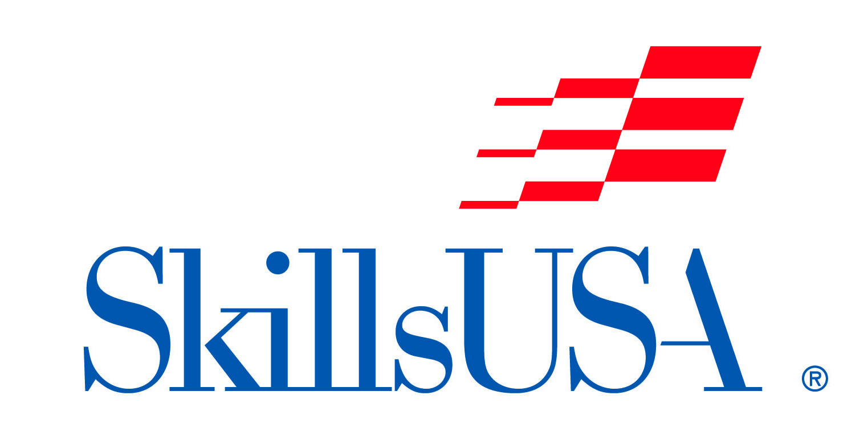
“TOTAL STYLE”
Student Manikin Competition
(Completed-In-Advance Showcase Design)

Date/Time: Saturday, October 21, 2023
Check-in 8:00-9:00am.
Location: NC State Fair, Raleigh, NC.
Entry Fee: $20 per contestant

The “Total Style” Student Manikin Competition is open to all NC Cosmetology students. SkillsUSA membership is not required to compete.

Registration Instructions:
Please complete the form online at: skillsusanc.org/state-fair-events

Contest Information:
This is a manikin styling showcase competition, where all hairstyling has been completed PRIOR TO the competition day, and the styled manikin is brought to the competition site for showcasing and judging.

2 pages need to accompany the completed manikin –
- Written Description of your style, process, idea
- Photos - 1 page of photos showing process of progress (example – manikin before styling, 1 or more steps through the process, etc).

A table will be provided for you to display your manikin as well as your description and photos. Since the only items you will need to provide is a completed/styled manikin head and 2 pages (identified above), your space allowance will be 2.5’ wide by 1.5’ deep.

Manikin: Student’s Choice

Manikins will be judged in the following categories:
- Creativity
- Originality
- Execution
- Adaptability
- Total Look

SHOW YOUR CREATIVITY!!!

Hair coloring, hairstyling, haircutting, ornamentation, use of extensions, make-up, lashes, jewelry or props are the competitor’s choice.

- All styling and make-up must be applied in advance
- Any ornamentation must be applied in advance

Schedule:
8:30 AM – 9:30 AM Competitor/ Manikin check-in & Set-up
10:00 AM – 12:00 PM Judging
1:30 PM – 1:45 PM Presentation Parade (if contestant is present)
1:45 PM – 2:00 PM Announcement of Winners

Cash Prizes will be awarded to the top (3) contestants.

(Please allow all manikins to remain on exhibit until Competition ends at 2:00pm).

All decisions of the judges are final.

For additional information please contact:
Morris “Boz” Boswell - Competition Chairperson
mbos324556@aol.com or (336) 214-3730
or the SkillsUSA-NC Office – 919-675-1241 or info@SkillsUSAnc.org

