SkillsUSA 2024 Additive Manufacturing State Challenge

Medallion Models

Welcome to the “logo Medallion” challenge!

The task at hand is to design an eye-catching medallion that represents your school, yourself, mascot, state, country, event, or hobby.

Design Examples:
- Bump Maps
- Displacement Texture
- Color/Material Changes
- Embossed/Debossed Text
- Motion

Example of a Basic Design
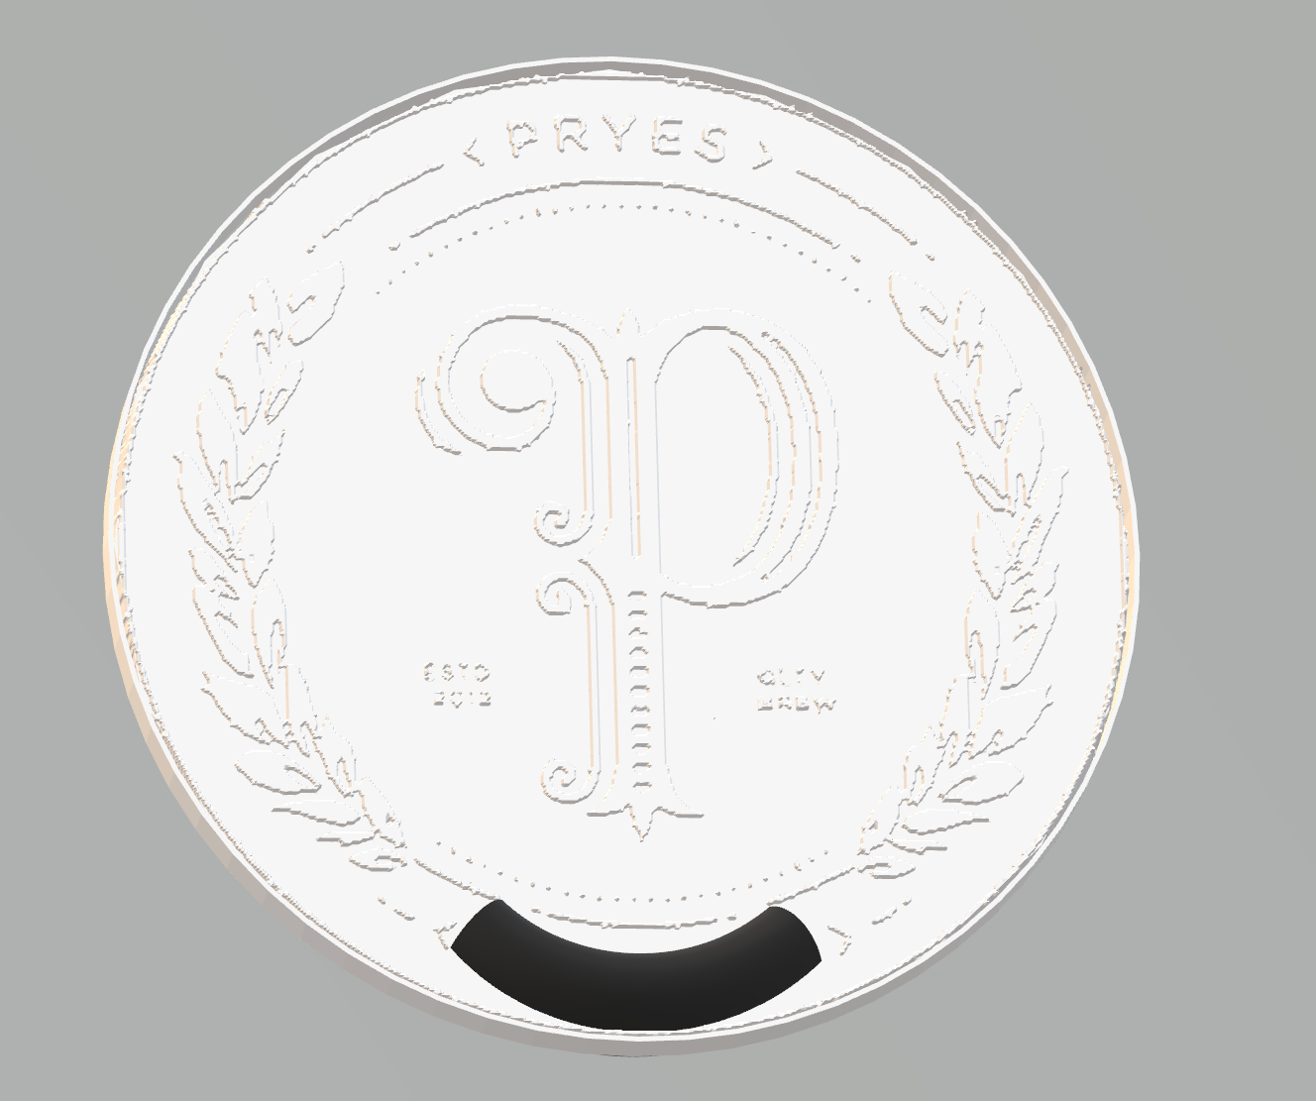

Competition Requirements

- The design must be completely 3D printed.
- The design can be 3D printed using any technology.
- The design must contain at least two legibly printed words.
- The design can contain 3D printed bodies that are glued together for the final part.
- Parts can be colored or painted.
- The printed design must have a minimum of (1) moving bodies.
- The design must be at least 3” x 3” x ¼”
- 3D Printed Design - Students must create a design that:
  - Is original and designed by competitor.
  - Print all parts in less than 8 hours.
  - Uses less than 5 cubic inches of model and/or support combined for all parts.

- Students need to bring their final prints with them on the first day of the contest so that students can test, assemble/modify and be evaluated.

Tips for Competitors
Here are some tips to maximize the points awarded to you:
- Build debossed text on a horizontal surface for best results. This may require building the part on its edge or standing up.
- Paint 3D is a free tool to help design the part.
- Try to leverage a design with multiple printed colors or technologies for a more creative part.
- Leverage post-processing techniques to smooth or color printed bodies.
- Additional moving parts may add to your score but can produce more points of failure on the final assembly.
- Use online resources (YouTube, GrabCAD Tutorials)
- Whenever intellectual property (IP) deters you from a project, try using approximate geometries to communicate the design intent.
- Optional design for additive manufacturing learning resources:
- Stratasys Think Additively™ Masterclass:
  - https://youtube.com/playlist?list=PLUYaY5EIPtNBdU-s-7l9rl05lBHHlTarI

2024 SkillsUSA State Conference Agenda

Tuesday Apr 23, 2024
12:00 - Orientation
12:15 - Collect Engineering Notebooks
12:30 - Teams are Given the Onsite 2024 State Design Challenge
4:00 - Design Challenge ends
- Teams must submit their design to judges via USB drive

Wednesday Apr 24, 2024
8:00 - Additive Manufacturing Written Test
8:30 - Team Presentations
9:45 - Break
10:00 - Onsite 2024 State Design Challenge Testing
- Teams will be given their designs (printed parts)
- Assemble designs
11:00 - Teams will Present their Onsite 2024 State Design Challenge to judges.
- Test Designs
12:00 - Competition ends.
- Teams are responsible for cleaning up the competition area

State Competition Procedure
Before or on competition day:
- Students submit Engineering Notebook (See engineering notebook guidelines below.)
- Students submit print files in both CAD (.step, .iges, .sldprt, etc.) and mesh (STL, IPT, 3MF, OBJ, etc.) format.
- Students submit physical parts.
- Students submit final assembly, if applicable.
- Students submit their presentation.

State Competition Judging Criteria

- The Engineering Notebook should contain robust content, including, at a minimum, the following:
  - Be clearly labeled with competitor name(s), date and page # on each page.
  - Begin with a problem statement.
  - Include discovery and documentation of approach to solve problem.
  - Include sketched design concepts with critical features labeled.
  - Critical dimensions clearly labeled in design sketch.
  - Considerations for designing for additive manufacturing distinctly addressed (i.e., part strength, part orientation) especially including any expected risks during printing.
  - Screenshots of the print time and material usage for all printed parts
  - Design decisions and alternatives are documented and evaluated thoughtfully.

- The design must adhere to the Competition Requirements stated on the prior page.

- Quality of final assembly
  - Does it perform the function in the manner it was designed to do?
  - Does it meet all requirements in the competition guidelines?
  - Do inserted components or multiple printed parts mates together properly?
  - Did the students design the part with additive manufacturing in mind?
  - Is there sufficient tolerance between parts for movement?

- The design must illustrate best practices for “design for additive manufacturing (DFAM)”. Below are some potential DFAM metrics to optimize for.
  - Build Time
  - Post-Processing/Support Removal Time
  - Functionality Optimization (gear ratio, pliability, strength, etc.)
  - Monetary Savings
  - Material Consumption
  - Energy Usage
  - Component Consolidation (lack of store-bought hardware)
  - Lightweighting for Ergonomics

- Presentation Criteria
  - The team clearly describes their understanding of the problem to be solved.
  - Design Process: good design logic is used for key design choices. Intentional and well-communicated
  - The presentation is professional and well-rehearsed.
  - The presentation emphasizes quantitative improvements (measured and estimated) of the time, quality, or cost of the improvement as well as any DFAM tactics employed.
  - Practical evaluation: team demonstrates visually (videos, photos, drawings, animation, etc.) the task they improved, both before and after.

