DRONE PILOT 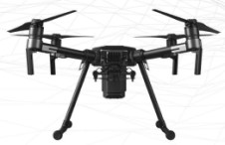

PURPOSE
To evaluate each contestant's ability to meet professional Drone Pilot requirements needed to successfully test, communicate, and present as a Drone FAA Certified Pilot.

ELIGIBILITY
Open to active SkillsUSA members who either currently or have been enrolled in an approved High School Drone curriculum program. Note: If any student or teacher is a certified FAA Part 107 pilot, they should possess their FAA and NCDOT credentials to fly.

CLOTHING REQUIREMENTS
- Any official SkillsUSA dress is acceptable for this contest, seeing it crosses over into so many other areas.
- For outside flying, it is recommended that students use outdoor shoes. These shoes must be closed-toe for safety purposes.
- Hardhats, safety glasses, and High-viz vest will be required for outside flying.

Note: Contestants must wear their official contest clothing to the contest orientation meeting.

OBSERVER RULE
Observers will be allowed to see the hands-on competition outside the competition area, and also be allowed to see the presentation part of the contest in the presentation room provided space is available. No talking or gesturing will be permitted. No observers will be allowed in the assembly area. No member of the audience will be permitted to enter or leave the demonstration room while a contestant is speaking. No cameras, video recorders or audio recorders will be allowed by members of the audience during the presentation portion of the contest.

EQUIPMENT AND MATERIALS
- Supplied by the technical committee:
  - Stopwatchs
  - Hardhats for Judges
  - High-Res Safety Vest for the Judges
  - Safety Glasses for the Judges
  - NIST Testing Standards for NFPA 2400
  - Safety Cones and caution tape needed to secure contest location.
  - 30 question FAA 14 CFR Part 107 written test and answer sheets (or online)
  - Laptop, LCD Projector, and screen for presentation.
  - Search and Rescue Mission Scenario for use in developing the presentation.

- Supplied by the contestant:
  - The sUAS for competition, including all batteries and controllers as required. Any sUAS is acceptable that includes a minimum 32GB SD card.
  - A device that can access the internet such as a laptop or Chromebook with wireless access.
  - Airman Knowledge Testing Supplement (No markings in book).
  - The 5-minute max PowerPoint presentation of the mission plan on a USB drive for use during the oral presentation portion of the contest (to be completed prior to day of the contest). A hardcopy is also required.
  - All competitors must create a one-page resume and submit a hard copy to the technical committee chair at orientation. Failure to do so will result in a 10-point penalty.

ARRANGEMENT OF ROOMS
Oral presentation room: A room will be furnished with two tables, each with chairs for judges and a timekeeper/room monitor. Additionally a holding area will be required for contestants awaiting judging for the presentation.

SCOPE OF THE CONTEST
Knowledge Performance
There is a 30 question written knowledge test required for this contest based on the FAA 14 CFR Part 107.

Skill Performance
This contest assesses both Practical Skills required to fly a sUAS and the ability to determine the needs required to complete a job request from a customer.

Skills Contest Guidelines
- Presentation
  - Students will be provided a scenario on a mission prior to the contest date.
  - On the contest day, student will provide a written Mission Report to the Proctor upon his or her arrival in the testing room.
  - The student will bring the sUAS to the test location and demonstrate a preflight, simulated flight, post flight inspection and a debriefing of the mission including a hardcopy of presentation.
  - The student will demonstrate putting the sUAS back in service for transport and storage.
Note: There will be no actual mission flown. The sUAS will not be powered on during this process.
  - A Scoring rubric will be used.

- Flight Performance
  - The student will conduct maneuvers using their sUAS (provided by the school) to complete NIST evaluation components that include the use of videoing of the letters/numbers located in buckets.
  - All preflight, in-flight, and post-flight operations will be included in the contest.
  - Judges as as Visual Observer (VO).
  - Flights will be flown by the student pilot communicating with the VO (see skills-sheet).
  - The judge will evaluate the preflight, in-flight, and post-flight operations and use the video to judge NIST component of the contest.

  - NIST Standards for NFPA 2400 will be used for the flight portion of this contest. Information can be found at this link,
    - https://bit.ly/3cdvmx8

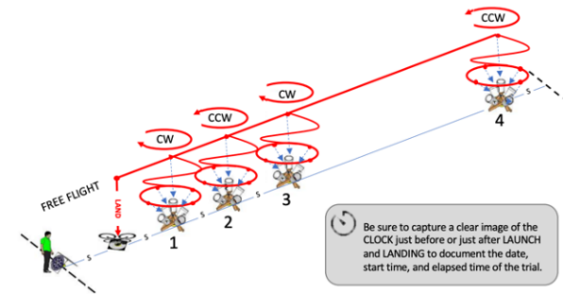
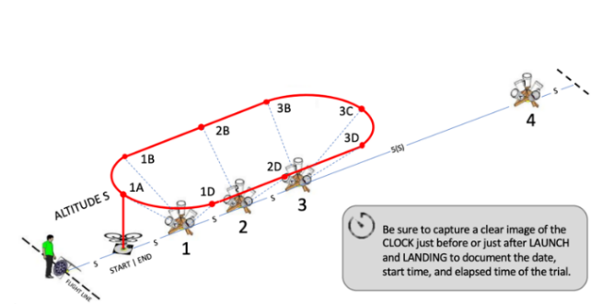

- Contest Rules
- sUAS, SD card with a camera provided by the high school.
- Flights will be flown by the student pilot with communications from a VO. The judge will act as the VO and participate in the verbal commands as needed for In-Flight communication requirements along with completing a judges skills sheet. Successful recording of steps and accurate capture of video images will determine points earned during the competition.
- In case of a tie, the flight time will be the deciding factor. Time starts when the sUAS lifts off and returns touching the launching pad.
- In the case of a second tie, the number of correct points scored on the written test will be added to the skills test score (note: this is double counting of test scores).

