Additive Manufacturing 2026
SkillsUSA State Challenge

Have questions: mdangelo@sme.org Coming soon website link team resources.

Welcome to the “Mini-Figure Catapult/Trebuchet Challenge” challenge!

The Additive Manufacturing (AM) contest evaluates students’ ability to design, prototype, validate, and communicate a functional mechanical device using only 3D-printed components.
Competitors must design a catapult or trebuchet capable of launching a standard LEGO® minifigure using no added materials, relying exclusively on the properties of 3D-printed plastics

Competitors create a fully additively manufactured launcher—catapult or trebuchet—where all energy storage and mechanical action originate from 3D-printed geometry alone, including:
- Printed torsion beams
- Printed elastic flexures
- Printed springs or spring arms
- Printed counterweights (printed material only)
- Printed tension/flexural systems
No external rubber bands, cords, metals, or weights may be used.

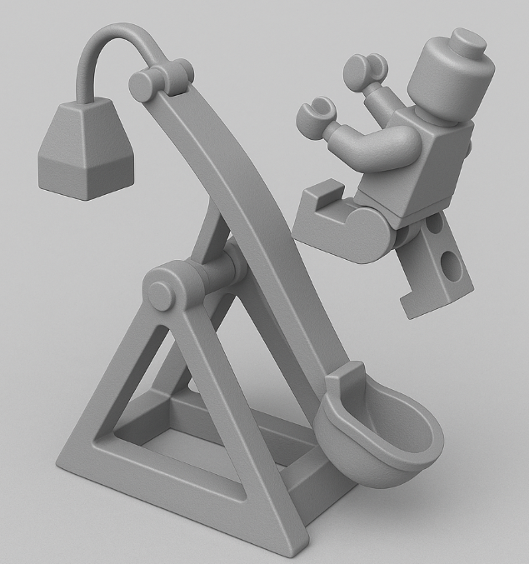

Competition Requirements

Design Requirements
Each team must design a launcher that:
- Launches a standard LEGO® minifigure (supplied by contest judges).
- Stores and releases energy using only 3D-printed material behavior:
  - Elastic bending
  - Torsional flexure
  - Printed leaf or coil springs
  - Beam deflection
  - Printed counterweight (printed plastic only)
  - No metal, rubber, glue, magnets, or external energy inputs.
- Operates using a catapult or trebuchet mechanism:
  - Catapult: energy stored in flexural or torsional arms.
  - Trebuchet: energy stored in printed counterweight or pendulum motion.
- Has a locking trigger mechanism
- Is safe and stable during operation.
- Requires no fasteners—all connections must be printed or snap-fit.
- May be a single print or multi-component assembly (can use multiple 3D printed material):
  - Bonus points for functionally integrated, single-print solutions.

Size & Print Constraints
- Fully assembled launcher must fit inside: 150 × 150 × 150 mm
- All components must be 100% 3D-printed
- Any 3D printer technology may be used:
  - FDM, SLA, DLP, PolyJet, SLS, SAF, MJF, etc.
- Any printable material is allowed:
  - PLA, ABS, TPU, Nylon, resin, PA11/12, etc.
- If multiple materials are used, all still must be 100% AM-produced.

Performance Requirements
During testing, each launcher must:
- Securely hold and release the minifigure.
- Launch the figure forward, not upward only.
- Complete three launches, which are measured for:
  - Distance
  - Repeatability (all three launches must land within a 6-inch diameter of first launch.
  - Safety and stability (No part interference, damage during operation, or unsafe trajectories)
Design Considerations

4.1 Energy Storage Methods (Allowed)
Teams may use:
- Printed flexible beams (like bow limbs)
- Printed torsion rods
- Printed leaf springs
- Printed coil springs
- Printed counterweights (solid or hollow filled only with printed material)
- Printed whip-action arms

4.2 Energy Storage Methods (NOT Allowed)
- Rubber bands
- Metal or lead weights
- Ball bearings
- Strings or ropes
- Electronics
- External kinetic input beyond human-triggered release

4.3 Stability & Safety
- Broad base recommended
- Ensure center of mass remains within footprint
- Avoid high-tension prints that may crack explosively
- Ensure minifigure is not struck by structural components during firing

4.4 AM Material Behavior Tips
- FDM: stronger along filament path; avoid layer-splitting by orienting beams horizontally
- Resin: brittle; great for fine details but avoid ultra-high deflection
- SAF/SLS: excellent for small flexures; nylon is durable
- Multi-material: optimize stiffness vs elasticity

4.5 Recommended Geometries
- Arched, tapered arms for elastic bending
- Hollow counterweights (printed-only mass)
- Integrated bearings or bushing pockets
- Snap-fit axles and pivot joints
- Lattice structures for energy absorption

State Competition Procedure
Before or on contest day:
- Students submit Engineering Notebook (Engineering notebook guidelines below)
- Students submit print files in both CAD (.step, .iges, .sldprt, etc.) and mesh (STL, 3MF, OBJ, etc.) format to Contests@SkillsUSAnc.org
- Students submit physical parts
- Students submit final assembly if applicable
- Students submit their Presentation

State Competition Judging Criteria

- The Engineering Notebook should contain robust content, including at a minimum the following:
  - Be clearly labeled with contestant name(s), date and page # on each page
  - Begin with a problem statement
  - Include discovery and documentation of approach to solve problem
  - Include sketched design concepts with critical features labeled
  - Critical dimensions clearly labeled in design sketch
  - Considerations for designing for additive manufacturing distinctly addressed (i.e. part strength, part orientation) especially including any expected risks during printing
  - Screenshots of the print time and material usage for all printed parts
  - Design decisions and alternatives are documented and evaluated thoughtfully

- The design must adhere to the Competition Requirements stated in the prior page.

- Quality of final assembly
  - Does it perform the function in the manner it was designed to do?
  - Does it meet all requirements in contest guidelines?
  - Do inserted components or multiple printed parts mates together properly?
  - Did the students design the part with additive manufacturing in mind?
  - Is there sufficient tolerance between parts for movement?

- The design must illustrate best practices for “design for additive manufacturing (DFAM)”. Below are some potential DFAM metrics to optimize for.
  - Build Time
  - Post-Processing/Support Removal Time
  - Functionality Optimization (gear ratio, pliability, strength, etc.)
  - Monetary Savings
  - Material Consumption
  - Energy Usage
  - Component Consolidation (lack of store-bought hardware)
  - Lightweighting for Ergonomics

- Presentation Criteria
  - The team clearly describes their understanding of the problem to be solved.
  - Design Process: good design logic is used for key design choices. Intentional and well-communicated
  - The presentation is professional and well-rehearsed
  - The presentation emphasizes quantitative improvements (measured and estimated) of the time, quality, or cost of the improvement as well as any DFAM tactics employed.
  - Practical evaluation: team demonstrates visually (videos, photos, drawings, animation, etc.) the task they improved, both before and after.

Grading Rubric
GR.1 Launch Performance — 35 pts
- Distance (best of 3 launches): 25 pts
  - Compare to peer competitors
- Consistency: 5 pts (all 3 figures land within a 6-inch diameter)
- Safe trajectory & controlled release (no interference or damage to parts while operating): 5 pts

GR.2 DFAM Execution & Print Quality — 20 pts
- Efficient use of AM geometry
- Thoughtful layer orientation
- Integrated mechanisms (springs, hinges, etc.)
- Complexity that adds functional value
- Built in locking trigger
- Clean print
- Quick assembly
- Good tolerance

GR.3 Engineering Notebook — 15 pts
- Completeness
- Technical clarity
- Analysis & iteration
- CAD quality

GR.4 Presentation — 15 pts
GR.5 Knowledge Exam — 15 pts
Pass with 70% or better or Fail

Additive Manufacturing Technology Resources:

The national technical committee provides a webpage with resources available for the previous NLSC.

State technical chairs, advisors, and students can use these resources to prepare for the competition. For more information visit: https://skillsusa-amchallenge.my.canva.site/

