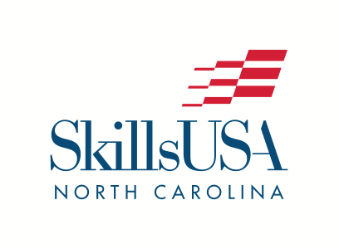
P.O. Box 88
Oxford, NC 27565
Phone: (919) 675-1241
info@SkillsUSAnc.org
www.SkillsUSAnc.org

2026 PRESS RELEASE
FOR IMMEDIATE RELEASE

June 8, 2026 - NAME, AGE, of CITY, NC, has WON or RANKED and/or received a Skill Point Proficiency Certificate or participated in the SkillsUSA national championship competition in NAME OF CONTEST. The SkillsUSA Championships took place in Atlanta June 1-5, 2026, as part of the 61st SkillsUSA National Leadership and Skills Conference (NLSC), a showcase of career and technical education students. During the conference, over 19,000 people attended the conference, with over 7000 outstanding career and technical education student state contest winners competing in 115 different hands-on trade, technical and leadership contests. 530 North Carolina participants from 42 high schools, 26 community colleges and 5 middle schools participated in the SkillsUSA National Leadership and Skills Conference.

FIRST NAME is a GRADE at SCHOOL NAME. [Add a quote here. Example: “We are very proud of [John’s] accomplishments,” said [Sam Smith, John’s] advisor at [Monroe.] He/She and the other students that participated in the NAME CONTEST competition are true champions in their dedication to excellence in their trade and their leadership skills.

During the national competition, STUDENT NAME and other students worked against the clock and each other, proving their expertise in occupations like electronics, computer-aided drafting, precision machining, automotive, welding, medical assisting, cosmetology and culinary arts. All contests are run with the aid and support of industry, trade associations and labor organizations, and test competencies are set by industry. In addition, leadership contestants demonstrated their skills in several Leadership Development competitions, which included both prepared and extemporaneous speaking, engaging in both individual and team presentations.

Top student winners received gold, silver and bronze medallions. Many also received prizes such as tools of their trade and/or scholarships to further their careers and education. The SkillsUSA Championships is for high school, middle school and college-level students who are members of SkillsUSA.

North Carolina was very well represented in the SkillsUSA Championships, earning a total of 79 medallions – 25 gold, 23 silver, and 31 bronze medallions.

SkillsUSA is a nonprofit partnership of education and industry founded in 1965 as Vocational Industrial Clubs of America (V.I.C.A.) to strengthen our nation’s skilled workforce. Driven by employer demand, SkillsUSA helps students develop necessary personal and workplace skills along with technical skills grounded in academics. This SkillsUSA Framework empowers every student to succeed at work and in life, while helping to close the skills gap in which millions of positions go unfilled. Through SkillsUSA’s championships program and curricula, employers have ensured schools are teaching relevant technical skills, and with SkillsUSA’s new credentialing process, they can now assess how ready potential employees are for the job. SkillsUSA has hundreds of thousands of members nationwide in high schools, middle schools and colleges, covering over 140 trade, technical and skilled service occupations, and is recognized by the U.S. Departments of Education and Labor as integral to career and technical education. With the addition of our alumni, membership last year was over 440,000. SkillsUSA receives in-kind and financial support from more than 650 national partners. SkillsUSA has served more than 14 million members since 1965. For more information, go to SkillsUSA.org and SkillsUSAnc.org .

###

