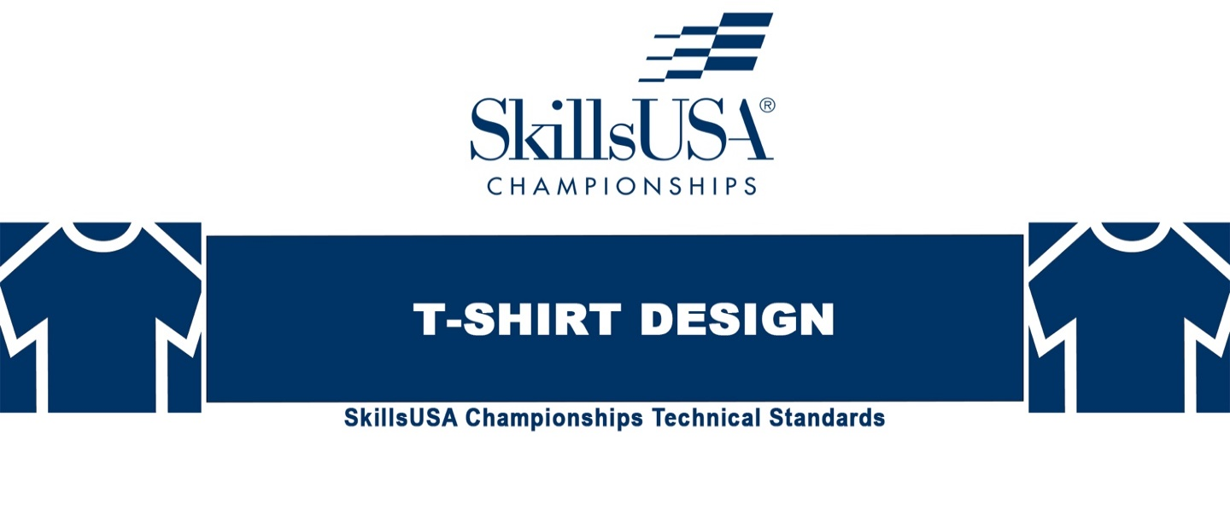
NORTH CAROLINA
CONTEST RULES
2022-23

Purpose
To evaluate a competitor’s creative, technical and oral presentation skills and recognize outstanding students for excellence and professionalism.

First, download and review the General Regulations at: http://updates.skillsusa.org.

Eligibility
Open to active SkillsUSA members enrolled in career and technical programs. Each state may send one middle school, one high-school and one college/postsecondary competitor.

Clothing Requirements
Class A: SkillsUSA Official Attire
Official SkillsUSA red blazer or official SkillsUSA red jacket
Button-up, collared, white dress shirt (accompanied by a plain, solid black tie or SkillsUSA black tie), white shirt (collarless or small-collared) or white turtleneck, with any collar not to extend into the lapel area of the blazer, sweater, windbreaker or jacket
Black dress slacks or black dress skirt (knee-length at minimum)
Black dress shoes
Note: Wearing socks or hose is no longer required. If worn, socks must be black dress socks and hose must be either black or skin-tone and seamless/nonpattern.

**North Carolina Contest Adjustments from the National Contest:
Items highlighted in GREEN and identified as NLSC indicate National Competition Requirements that we will not require for our NC competition, but you need to be aware of these if you advance to the national competition.
Items printed in RED refer to items required for our NC Contest which are not required for the national competition.

Equipment and Materials
- Supplied by the technical committee:
- Timekeeper and judges
- All necessary information for the judges and technical committee
- NLCS ONLY: Stand to display T-shirt.

- Supplied by the competitor:
- A print (on paper) Design to display, no larger than 8.5x11. (This is in place of the printed T-shirt that will be required at the national conference competition -- NEW this year).
- A design notebook submitted in a three-ring binder with supporting materials for the presentation portions of the competition.
- All competitors (except for middle school students) must create a one-page resume. See “Resume Requirement” below for guidelines.
- NLSC ONLY:
  - Printed T-shirt. Size Medium or Large.
  - Official SkillsUSA 3-ring binder is required

Resume Requirement
Competitors (except for middle school students, who are exempt from this requirement) must create a one-page resume which will be the final page of the notebook for NC (see below) to submit online. SkillsUSA national competitors should submit their resume by June 1. Failure to submit a resume will result in a 10-point penalty.
Your resume must be saved as a PDF file type. If you need assistance with saving your file as a PDF, visit the Adobe website for more information.

Prohibited Devices
Cell phones or other electronic devices not approved by a competition’s technical committee are NOT allowed in the competition area.

Scope of the Competition
The competition consists of two parts:
- Evaluation of the T-shirt design through one visual presentation.
- Evaluation and verbal defense of the design decisions through an oral presentation, which will include a question-answer session.

Knowledge Performance
There will be no skill-related written test. Competitors are required to take the SkillsUSA professional development test. Middle school competitors are exempt from testing requirements.

Skill Performance
The competition is designed to assess the ability of the competitor to design and produce a rendering of a state conference T-shirt design, as well as give a presentation regarding all aspects of his or her creation of the design.

Competition Guidelines
- Two presentations are required: a visual presentation and an oral presentation.

- A space will be provided for you to display your T-shirt and notebook only to promote your design to the public and for viewing at the national conference. You will have no more than a 28" x 28" table space for this display. Your entry submitted for judging will also be in this space. This display can be used in your presentation. **NO TRI-FOLD POSTER BOARDS ARE ALLOWED.** Penalty Points will be assessed if your design is outside of these dimensions.

- (NLSC ONLY) Design should be printed on a medium or large shirt for best fit on the supplied T-shirt display stand.

- FOR NC Contest: A printed Design for display, no larger than 8.5x11.

- Preferably, entries will be created in a design software package such as Adobe Illustrator or Adobe Photoshop, or Freehand. Entries may also be hand-drawn, painted, or rendered in colored pencils or markers.

- The visual presentation will consist of your printed T-shirt a Printed Design (on paper) for the NC Contest and a design notebook to be submitted in a three-ring binder.

- The design notebook will contain 8.5" x 11" drawings, sketches, thumbnails, roughs, composites, lists, etc. that were used during the design process. You may place any design asset or element that was used to create the design in this notebook to aid in your oral presentation.

- The design notebook must include the following in this order:
  - Title Page. Include name of chapter, school name, school address and school telephone number.
  - Table of Contents. This should be page 1. The table of contents will follow the presented order list with page numbers.
  - Entries must be submitted in an official SkillsUSA any three-ring binder for the NC Contest. The notebook will contain no more than 25 sheets of 8.5" x 11" paper. Only the front surface of the 25 sheets may be filled.
  - For NC only – Contestant RESUME’ should be the LAST page of the notebook, and will not cause a penalty if it is page 26.
  - Penalty: Five points per surface will be deducted for exceeding these maximums.

- Artwork submission is 8.5" x 11". The artwork should be a comprehensive design and be displayed as a “proof” — a professional impression of the final design. All entries must be rendered in color. Entries must be submitted to the technical committee chair at orientation. Failure to do so will result in a penalty determined by the official scorecard.

- State competition designs cannot be changed for national competition submission. There is no opportunity to “tweak” the design after it has been judged the state winner.

- The front-only T-shirt design will include elements to represent your state and SkillsUSA. This should be a shirt that a SkillsUSA member would like to wear.

- The following text must appear on the T-shirt design: “SkillsUSA North Carolina” and the current year of the national competition.

- The SkillsUSA emblem or SkillsUSA logo (or elements of either one) should not appear on the design.

- All copyright laws must be followed in the creation of the design and presentations.

- T-shirt design submissions must be turned in at the competition orientation meeting.

- The T-shirt designer must specify the color of the shirt the artwork is intended to be printed onto.

- Competitors will deliver a five- to seven-minute 2-minute presentation and question/answer session regarding their design. They should display all their preliminary research and work (sketches, layouts, etc.) in the visual presentation (notebook).

- Talking points should include:
  - How he or she came up with the design
  - The process used in developing their design
  - The design’s unique qualities
  - Why other students/advisors would want to wear it
  - A defense of design decisions based on the question/answer session
  - Describe the printing method of the entry.
NOTE: All of these “Talking points” must be included and clearly identified in the notebook.
Note: No extra time will be given if oral presentation does not leave time for the question/answer session.

- Contestants are to submit a Packaged Native (Original) File
- The Original Source File (psd, ai, indd, etc.) NOT compressed or flattened
- Fonts
- Colors
- links to images

************************************
North Carolina Process

- NOTEBOOK ELECTRONIC SUBMISSION:
All contestants are required to submit an electronic copy of their notebook.
The Resume’ should be the LAST page of their notebook.

- ORIGINAL SOURCE FILE SUBMISSION:
Psd, ai, indd, etc., NOT Compressed or Flattened.
A Packaged Native File is requested, but not required.

* Notebook (including Resume’) and Original Source File must be submitted through this Google Drive portal
https://drive.google.com/drive/folders/1lNuemiQooAR92D4T-Lkyui9c6vbPpDkf?usp=sharing
Deadline for electronic submission of these items is TUESDAY APRIL 4.

- ORAL PRESENTATION (on site):
In 2 minutes or less, contestant will discuss –
- The Design’s unique qualities
- Why other students/advisors would want to wear it
Possible: Judges’ Questions to follow.

************************************

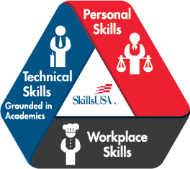
Standards and Competencies
TD 1.0 — SkillsUSA Framework
The SkillsUSA Framework is used to pinpoint the Essential Elements found in Personal Skills, Workplace Skills, and Technical Skills Grounded in Academics. Students will be expected to display or explain how they used some of these Essential Elements. Please reference the graphic above, as you may be scored on specific elements applied to your project. For more, visit: www.skillsusa.org/about/skillsusa-framework/.

TD 2.0 — Understand general design industry terminology and concepts
- Define, explain and describe various concepts related to typography, elements of design, digital images, artwork and the printing process

TD 3.0 — Demonstrate mechanical skills by creating a design on the computer within a specified amount of time
- Recall understanding and skills necessary to prepare art electronically
  - Implement correct size and orientation of design. Competitor should recall knowledge and appropriate use of industry standard hardware and software.
  - Implement correct size and placement of elements
  - Implement correct use of typography
  - Implement assignment of proper color to elements

TD 4.0 — Administer creative skills by solving a graphic design problem relevant to the skill set required for the design industry
- Apply understanding and skills necessary to create a variety of thumbnails and ideas for a given design problem
  - Implement correct number, size, scaling and color requirements of thumbnails as defined by the technical committee
  - Implement media (markers, color pencils, etc.) in the creation of thumbnails
  - Demonstrate professional presentation and technical execution of thumbnails
- Apply understanding and skills necessary to create roughs developed from thumbnails for the given design problem
  - Implement correct number, size, scaling and color requirements of thumbnails as defined by the technical committee
  - Exhibit the development of ideas from the thumbnail stage
  - Implement media (markers, color pencils, etc.) in the creation of roughs
  - Demonstrate professional presentation and technical execution of roughs
- Administer industry standard hardware and software in the creation of the project
  - Implement correct size and format for the design of the comprehensive portion of the competition. Exhibit the development of ideas from the rough stage
  - Implement clip art, original art and designs in the creation of the comprehensive
  - Demonstrate professional presentation and technical execution of the comprehensive

TD 5.0 — Complete an oral professional assessment in a simulated customer situation
- Perform customer-service-related activities when relating to a customer
  - Explain the function of the customer service representative
- Communicate professionally with technical knowledge
  - Describe the workings of a production environment
  - Explain the nature of work performed and requirements of customers
- Respond quickly, accurately and professionally in a customer situation

TD 6.0 — Demonstrate an understanding of the SkillsUSA Framework in the presentation.
- Apply job specific skills to the project
  - Explaining the research done for the state the T-shirt is representing.
  - Explain the design rationale, i.e., why this design was chosen based on the research.
- Presenting personal skills
  - Explain the integrity of the design
  - Share some of the hardships that came with executing the T-shirt, and how those were overcome.
- Apply workplace skills.
  - Explain the process of communicating, organizing, and managing the process in which this T-shirt was created.
  - Provide examples of the commitment to leadership to complete this project.

