
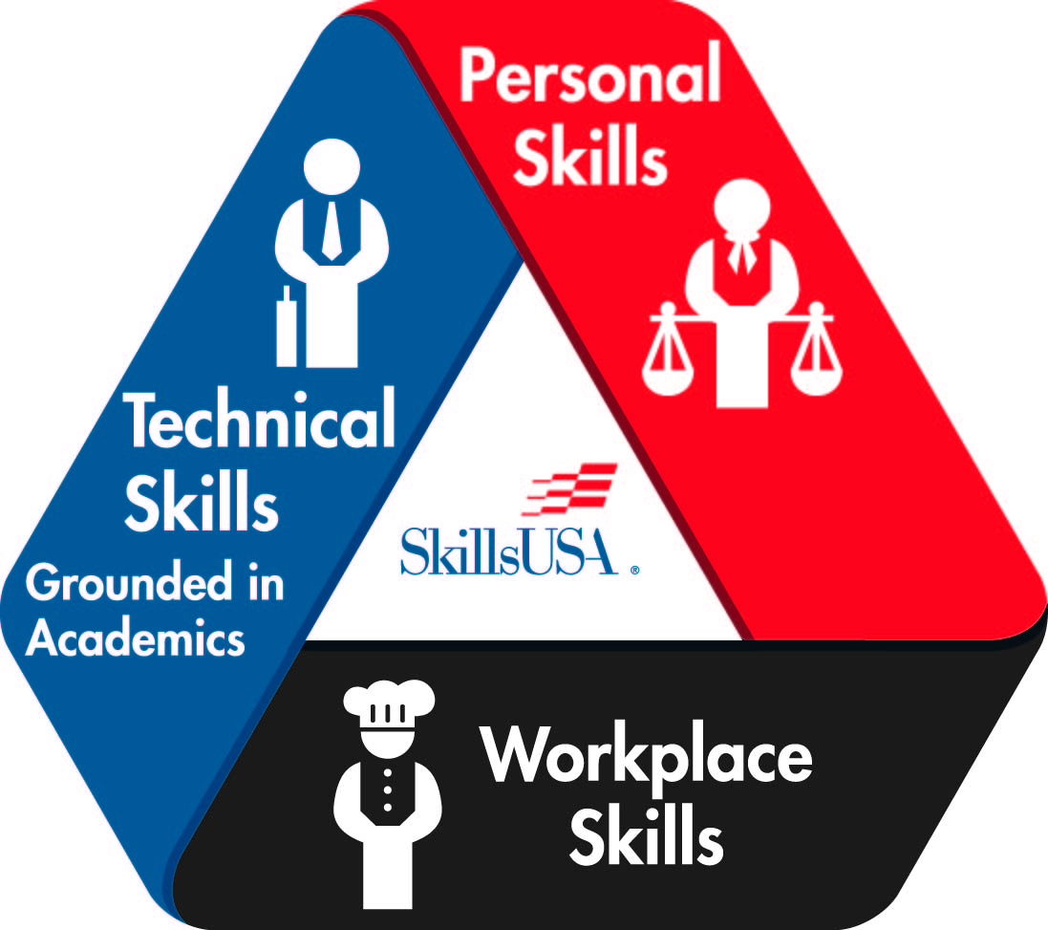
SkillsUSA NORTH CAROLINA
EMERGENCY MANAGEMENT
POSTER CONTEST
(REGIONAL/STATE-ONLY CONTEST)

PURPOSE
Evaluate the contestant’s ability to develop and prepare a SkillsUSA promotional poster and present the content to the judges.

CLOTHING REQUIREMENTS
SkillsUSA Leadership Attire or Businesslike Attire.

ELIGIBILITY
Open to active SkillsUSA members enrolled in Public Safety Academy courses.

EQUIPMENT AND MATERIALS
- Supplied by SkillsUSA/Host:
- Copies of regulations.
- Tables.
- Pencils.
- One room.

SCOPE OF THE CONTEST
- The poster shall be designed and constructed in advance of the competition day by one SkillsUSA member only.
- The theme for the poster will be the student’s choice. It must be an Emergency Management theme.
- Entries shall be constructed on 22” x 28” poster board.
- The entire poster must be HAND-DRAWN. Any part of the poster that is not hand-drawn will incur a penalty.
- Posters may not have any attachments on them (molding, framing, mockups, module, photographs, collages, stick-ons, glitter, etc.).
- A verification letter, signed by the advisor and principal, verifying that the poster was completed by the SkillsUSA member registered, must be attached to the back of the poster.
- Only students will be allowed to set up the posters according to instructions given by the contest chairperson or the conference program.
- The student will present the poster and its contents to the judges. Judges may ask questions.
- Failure to comply with any requirement listed above will result in a penalty for each rule violation.

SCORING
Educational Information Value – 200 pts
Layout and Design – 200 pts
Workmanship – 200 pts
Creativity and Originality – 200 pts
Current Theme Displayed on Poster – 50 pts
Poster Relates to an Emergency Management Subject or Theme – 50 pts
Oral Presentation – 100 pts

Clothing Penalty – 0 to -10 pts
Resume Penalty – minus 10 pts
Attachment Penalty / Anything that is not Hand-Drawn – minus 200 pts
Verification Letter – minus 200 pts

