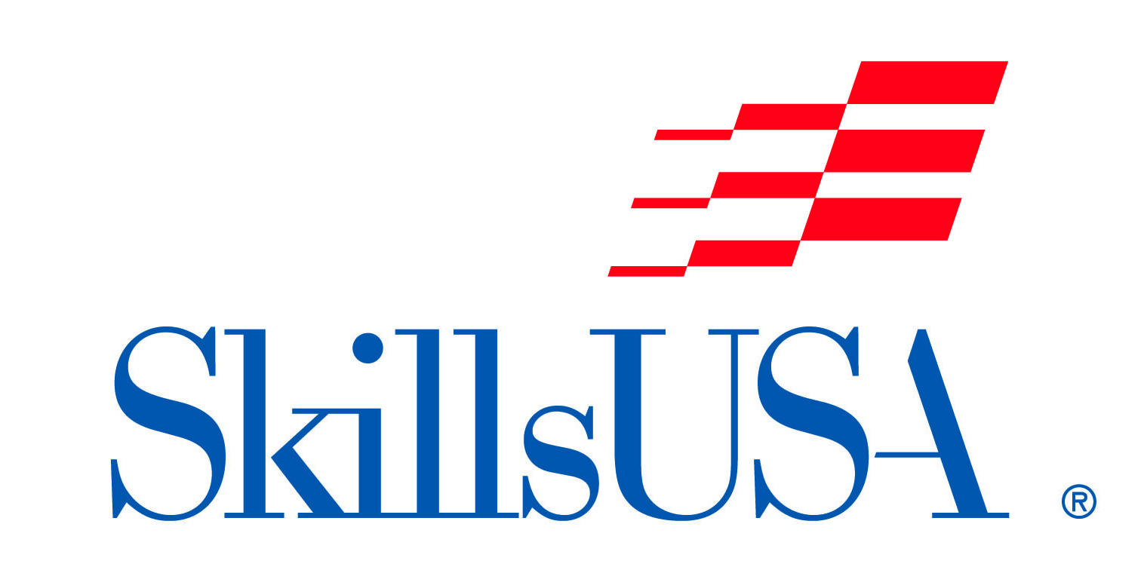
“TOTAL EVENING ELEGANCE”
Student Manikin Competition
(On-Site Design & Style)

Date/Time: Saturday, October 21, 2023
Check-in 8:00-9:30am.
Location: NC State Fair, Raleigh, NC
Entry Fee: $20 per contestant

The “Total Evening Elegance” Student Manikin Competition is open to all NC Cosmetology students. SkillsUSA membership is not required to compete.

Registration Instructions:
Please complete the form online at: skillsusanc.org/state-fair-events

Contest Information:
This is a manikin styling competition. All hairstyling must be completed at competition site. Manikins may be pre-colored, cut, set or pin curled prior to competition. If manikin is pre-set or pin curled the rollers and clips must remain in the hair until the competition begins.

Electricity will be provided -- PLEASE BRING A DROP CORD IF NEEDED.

Manikin: Student’s Choice

Manikins will be judged in the following categories:
- Creativity
- Originality
- Execution
- Adaptability
- Total Look

Competitors are required to participate in the Presentation Parade displaying their manikin

SHOW YOUR CREATIVITY!!!

Hair coloring, hairstyling, haircutting, ornamentation, use of extensions, make-up, lashes, jewelry or props are the competitor’s choice.

- All styling and make-up must be applied on-site
- Any ornamentation must be applied on-site
- Hair may be roller set, pin curled, extensions may be pre-added but there can be no signs of pre-combing.

Schedule:
9:45 AM Competitor Briefing
10:00 AM Competition begins
11:00 AM – 12:00 PM Manikin Styling
12:00 PM – 12:30 PM Judging
1:30 PM – 1:45 PM Presentation Parade
1:45 PM – 2:00 PM Announcement of Winners

Cash Prizes will be awarded to the top (3) contestants.

(Please allow all manikins to remain on exhibit until Fantasy Hair/Make-Up Competition ends at 2:00 PM).

All decisions of the judges are final.

For additional information please contact:
Morris “Boz” Boswell - Competition Chairperson
mbos324556@aol.com or (336) 214-3730
or the SkillsUSA-NC Office – 919-675-1241 or info@SkillsUSAnc.org

