Cosmetology Beginner Skills
(Please note major changes highlighted in yellow.)

PURPOSE
To evaluate each contestant’s preparation for employment and to recognize outstanding students for excellence and professionalism in the field of cosmetology.

ELIGIBILITY
Open to active SkillsUSA members enrolled in programs with cosmetology as the occupational objective.
Cosmetology students in Beginner Skills must have less than 450 hours.
Copy of dated time sheet, instructor signed and school sealed.

CLOTHING
- White Polo shirt
- Black Dress Slacks (no jeggings or leggings, no spandex, no yoga pants, no skin-tight pants, no denim)
- Black belt with no ornamentation (if slacks have belt loops)
- Black dress socks or black or skin-tone hose is allowed under slacks
- Black leather work shoes (closed toe).
Jewelry is allowable, as long as it conforms to professional attire and is not a safety issue.
If students show up in attire that is unprofessional, they are not allowed to compete.

EQUIPMENT AND MATERIALS

Supplied by the Technical Committee
- Tables
- Timer / time-keeper
- Electrical outlet
- First Aid Kit and blood Spill Kit
- Contestant's diagram/picture of haircuts
- All necessary information for the judges and tally committee.

Supplied by the Contestant
- 2 (Two) ”SAM II” Brown Manikins (One cut & preset; One cut & ready to set) - SAM II BROWN DUO #S153-DUO with holder OR SAM II Brown #153 without holder.
Note: To purchase manikins, call Burmax 1-800-645-5118 Service Dept –
Ask for a SkillsUSA discount
- Manikin Stand/Holder (Do NOT bring a Tripod)
- Small broom and dust pan
- Pen or Pencil
- Note Pad (for Oral Communications Segment)
- Power strip with Surge Protector
- 1 Large Trash Bag for soiled linens/towels and such, no labelling needed
- Disinfectant spray
- Bags for dirty implements and equipment
- Resume
- COSMETOLOGY BEGINNER SKILLS KIT –
- Rollers necessary to complete set
- Pin curl clips
- Styling gel or product of choice
- Hair spray (can be aerosol) (COLOR Spray is NOT allowed)
- Rat tail combs
- Combs of choice
- Sectioning clips
- Spray bottle with water
- Magnetic rollers
- Roller clips
- Sectioning Clips
- Brushes
- Capes for wet and dry styling
- 5 towels
- Sanex Neck strips
- All-Purpose Cape

GENERAL CONTEST INFORMATION
- Contestant Folder – Contestants are to prepare a folder to present to the Chairperson at orientation. Contents of the folder should include:
- Copy of Cosmetology Beginner Skills Verification Form, instructor-signed.
- Resume – All contestants will turn in a typed, 1 page, professional resume.

- Cell phones or other electronic devices are NOT allowed in the competition area.

- Talking – No talking to other contestants, instructors, or audience members during the competition is allowed. Doing so may result in disqualification. If you have a question, raise your hand and a sage or the competition chairperson will see to your needs.

- Breaks – Breaks will be given during competition. Contestants are not allowed to leave the area except with a chaperone for restroom visits or emergencies. If contestant gets sick during the competition and need to leave the contest area, no extra time will be allotted.

- Work Time – You can begin the contest when the chairperson signals so and you must stop when time is called. Continuing to work will result in point deductions. All contestants must participate in all phases of the competition, including written (if applicable) and Oral Communications.

- Sanitation – Contestant must disinfect and clean-up their work station/area, which includes a total breakdown of their work station/area. 1 Trash Bag is required, no labeling needed. THIS IS NOT STATE BOARD SANITATION – Just what we are requiring for this competition. Sanitation for this contest includes –
- Sanitizing the workspace at the beginning,
- Sanitizing the workspace at the end,
- Items are not thrown on the floor throughout the competition, and
- All used items go in the trash bag.

- Upon completion of the competition – DO NOT Remove Manikins from the competition area until instructed to do by the contest chairperson.

- Secondary contestants will compete against secondary and postsecondary will only compete against postsecondary.

- JUDGES DECISIONS ARE FINAL

SCOPE OF THE CONTEST

Both Manikins are pre-cut with the same haircut for Segment 1 & 2 below

Segment #1 Roller Set on Manikin
- 60 minutes will be provided for this segment
- Competitor will perform a roller set – see diagram provided in this competition packet
- Upon completion or when time is called, the competitor will place the manikin in the designated judging area
- Sets will be judged based on the level of skill exhibited. For example, are rollers on proper bases, are proper clipping techniques used, etc.
- Clean and disinfect work area

Segment #2 Comb Out on Pre--Set Manikin
- 60 minutes will be provided for this segment
- Competitor will perform a comb out on a pre-set manikin that they bring with them (see diagram in packet)
- Comb outs will be judged on execution of back combing, back brushing, smoothing and overall likeness to the diagram
- The diagram used must be provided at the station while performing comb out
- Upon completion or when time called, the competitor will place the manikin in the designated judging area
- Clean and disinfect work area

SCORING INFORMATION
- Set on manikin - 450 possible points
- Comb out on pre-set manikin - 450 possible points
- Oral communications - 100 possible points
- Point Penalty Categories:
- Incorrect Manikin – 200 point deduction
- Late Arrival penalty – 200 point deduction
- Sanitation / Clean-up – up to 100 point deduction.
- Kit Check – up to 30 point deduction
- Clothing penalty – up to 10 point deduction
- Resume penalty – 10 point deduction

ORAL COMMUNICATIONS SCENARIO:
“BOOKING AN APPOINTMENT BY PHONE”

** All Cosmetology-related competitors will perform an oral interview.

- Mock telephone conversation scenario: Booking an appointment with a first-time client. The client is new to the area. The client will be booking the appointment in the cosmetology/contest discipline area that the students is competing in.
- Competitors may bring note pad and pencil to write down information.
- Judge will be seated across from the competitor acting as the client.
- Judging Criteria: (100 points)
- 10 pts - Pleasant voice
- 10 pts - Identified salon
- 10 pts - Identified stylist
- 10 pts - Asked for client’s first and last name
- 10 pts - Asked for client’s phone number
- 10 pts - Asked for type of service client is requesting
- 10 pts - Used client’s name at least once in the conversation
- 10 pts - Confirmed service to be done, time and date
- 10 pts - Suggested additional services
- 10 pts - Outstanding presentation

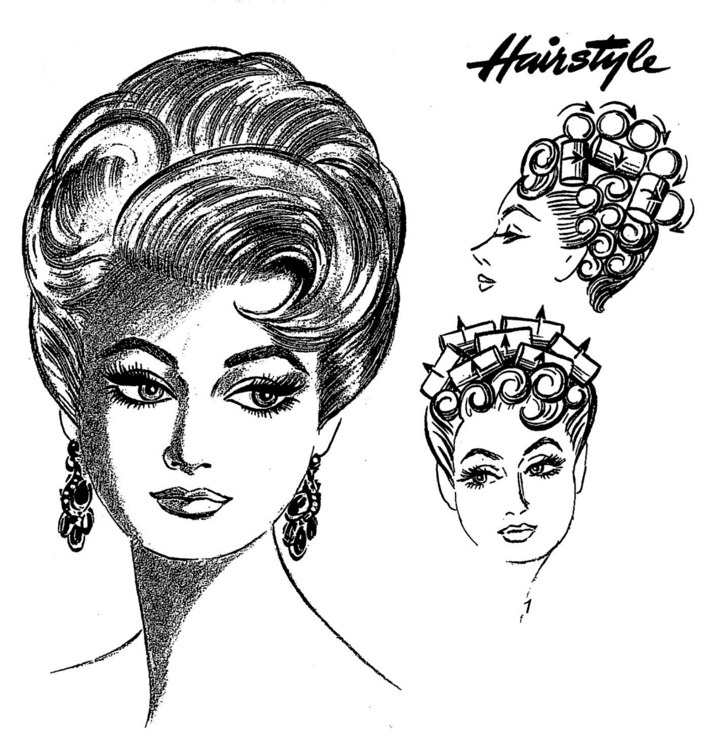

The hairstyle is a Roller set that blends into a tapered occipital neckline.
Emphasize height in the crown area and do not cover the forehead with bangs. The style should flow forward or away from the face, but in either case, kept away kept smooth and close at the sides. The nape should be short.

COSMETOLOGY BEGINNER SKILLS
CONTEST VERIFICATION FORM

Contestant: _____________________________________________________

School: ________________________________________________________

Contest: _______________________________________________________

______ I do hereby acknowledge that the contestant listed above has less than 450 hours of Cosmetology Instruction.

Signatures:

_______________________________ ________________________________
(Student Signature) (Print Name)

_______________________________ ________________________________
(Advisor Signature) (Print Name)

_______________________________
Date

** This completed and signed form MUST be brought with contestant to the contest orientation. Failure to provide this Verification Form to contest chairperson will result in a point deduction.

