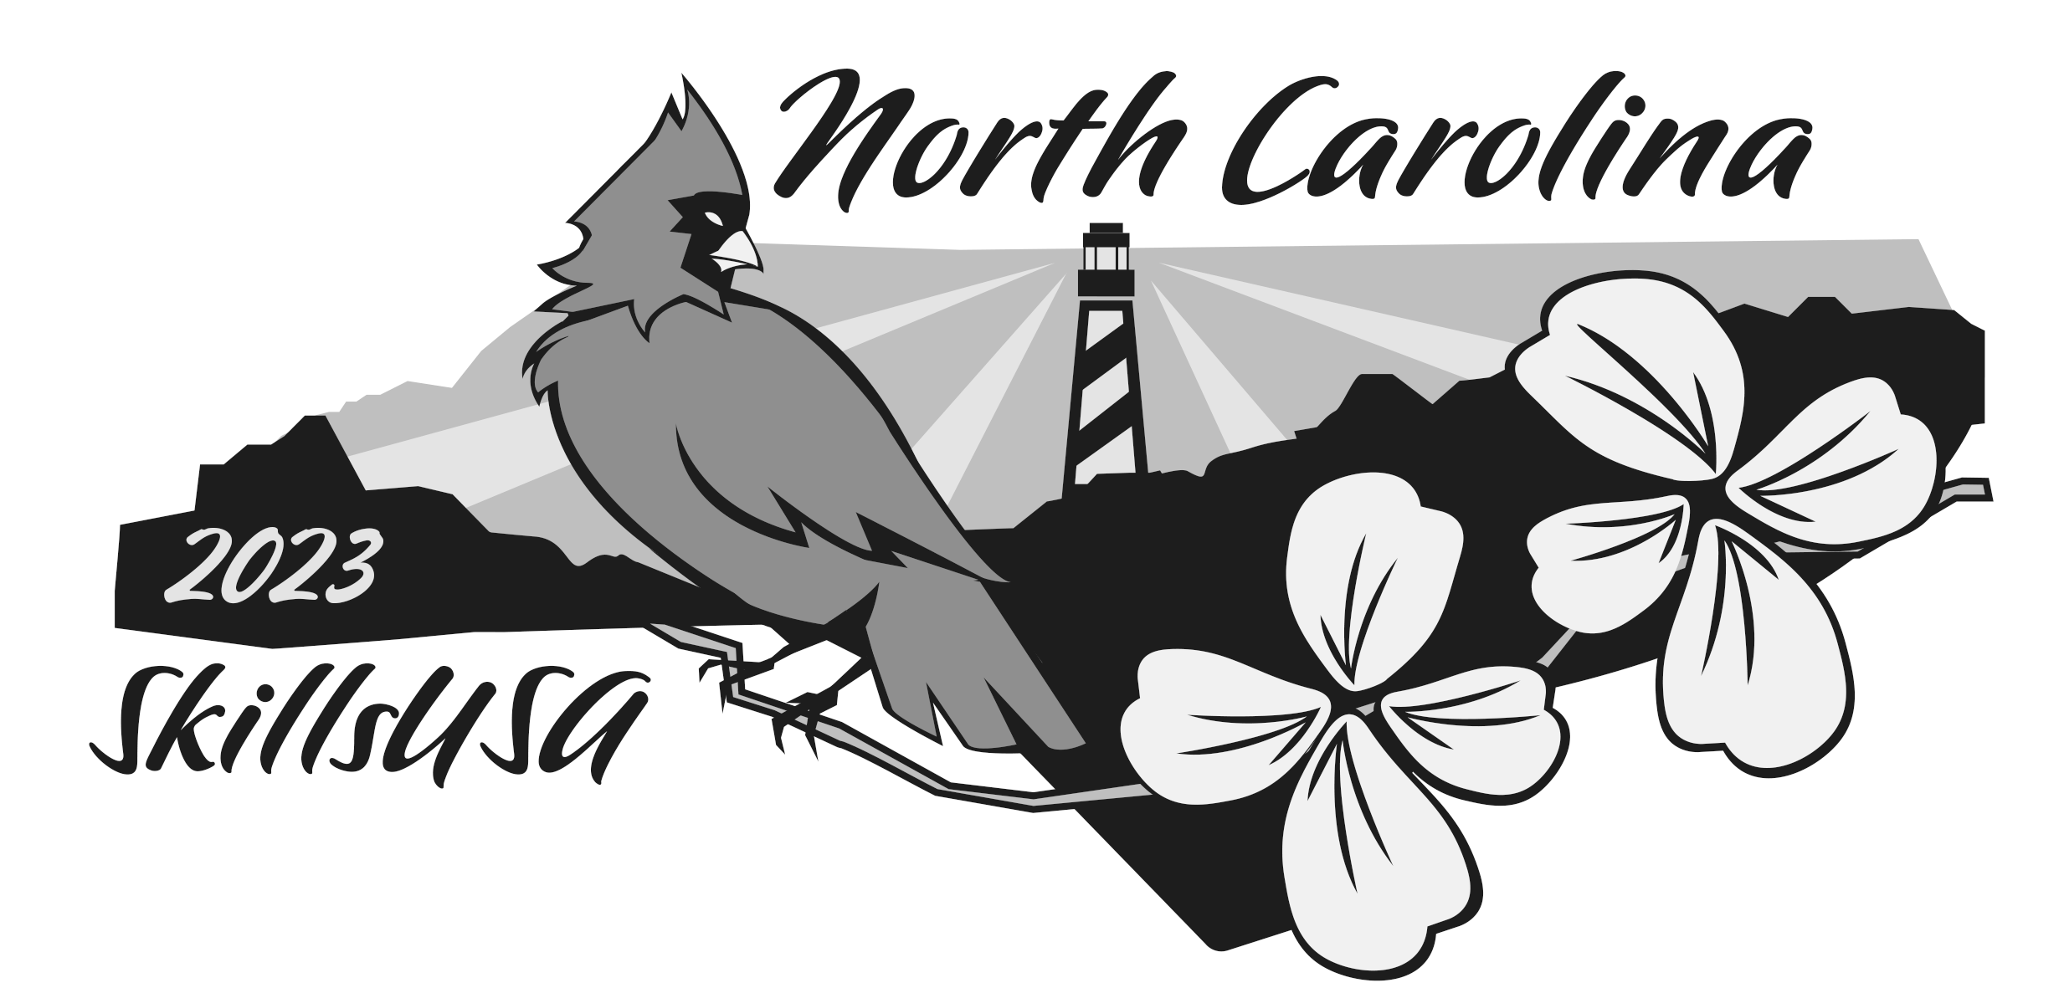

**State Leadership Workshop**

**Camp Dixie**

**October 1-3, 2023**

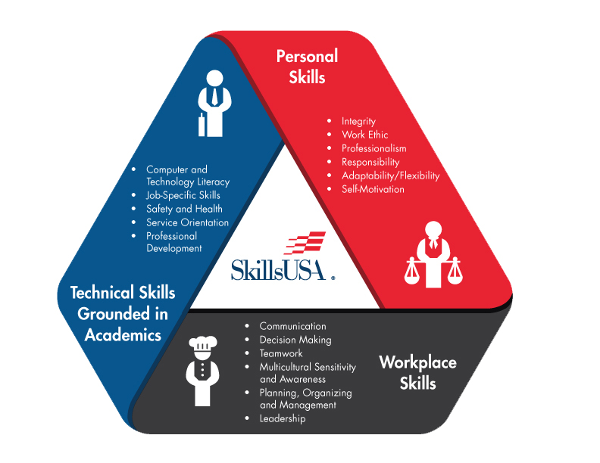

WELCOME to the SkillsUSA North Carolina STATE LEADERSHIP WORKSHOP at Camp Dixie! The next couple of days will be filled with high energy and a chance to bust out of your comfort zone. You will participate in the-time-of-your-life activities that will not only be fun but will also help you grow as a leader and as a person. Here you will work with other people from all over the state of North Carolina. You will bond and grow as a group and as an individual, as your chapter vies to win the coveted Dixie Cup. The competition is intense, the laughter is side splitting, the lessons are life-changing, and the memories are forever.

Get yourselves ready to do things you never thought you would do -- to make friends you never thought you would make and to have more fun at a leadership camp than you ever thought you could. Keep your mind open, your eyes focused and your hands involved – because this is something you will not soon forget.

Now is the time…get ready for a GREAT EXPERIENCE!

**2023-2024 SkillsUSA Theme:**

# *SkillsUSA: No Limits*

**LEADERSHIP COMPETENCY GOALS FOR THIS WORKSHOP:**

1. Gain a deeper knowledge and understanding of the Framework of SkillsUSA.
2. Develop teambuilding skills through active participation in team activities.
3. Demonstrate how to prepare and conduct a business meeting.
4. Prepare materials to use in SkillsUSA North Carolina statewide membership recruitment effort.
5. Develop public speaking skills.
6. Demonstrate proper social etiquette.
7. Learn Chapter Management techniques to use in your chapter.
8. Participate in and achieve requirements for state leader award.

### SkillsUSA Pledge

Upon My Honor, I Pledge:

To prepare myself by diligent study and ardent practice to become a worker whose services will be recognized as honorable by my employer and fellow workers,

To base my expectations of reward upon the solid foundation of service,

To honor and respect my vocation in such a way as to bring repute to myself,

And further, to spare no effort in upholding the ideals of SkillsUSA.

**SkillsUSA North Carolina**

P.O. Box 28064

Raleigh, NC 27611

919-675-1241

info@SkillsUSAnc.org

**Executive Council Members**

SkillsUSA North Carolina State Staff

## Paul Heidepriem, Executive Director

## Brandon Ramirez, State Leadership Coordinator

## Rod Lykins, Director of Membership & Curriculum

**SkillsUSA North Carolina 2023-2024 State Officers**

Jacob Blackman, President Midway HS Vernon Blackman, Advisor

Kayla Ingham, Vice President Pine Forest HS Sharon Huggar, Advisor

Reece-Anna Cribb, Secretary South Columbus HS Breanna Giddings, Advisor

Cameron Vaughan, Treasurer Lee County HS Chris Garner, Advisor

Wesley Conner, Reporter South Columbus HS Breanna Giddings, Advisor

Ruth Hall, Parliamentarian West Carteret HS Pam Zanaska, Advisor

Nathan Darnell, Historian Starmount HS Sandy Martin, Advisor

North Carolina Department of Public Instruction Partners

Trey Michael, State CTE Director [Trey.Michael@dpi.nc.gov](mailto:CPendergraft@dpi.state.nc.us)

Dr. David Barbour, T&I Education Consultant [David.Barbour@dpi.nc.gov](mailto:David.Barbour@dpi.nc.gov)

Jim Pressly, T&I Education Consultant [James.Pressly@dpi.nc.gov](mailto:CPendergraft@dpi.state.nc.us)

Dr. Nolan Fahrer, T&I Education Consultant Nolan.Fahrer@dpi.nc.gov

**NC Logo 1c**

**CAMP COUNCIL**

**CAMP DIRECTORS** Paul Heidepriem

Brandon Ramirez

Rod Lykins

**LEADERSHIP** Stephen Lupton, Former State & National Officer

**FACILITATORS:** Patrick Collins, Former State Officer

**SUPPORT ASSISTANTS:** Greeley Hibbard, Former State Officer

Carter Godwin, Former State Officer

Jenna McLamb, Former State Officer

Ashley Hill, Former State Officer

Kyle Martin, Former State Officer

Lauren Stone, Former State Officer

# Chapter A

**Education Bldg. – A**

Color: Green

Chapter Leaders: Reece-Anna Cribb, Nathan Darnell

# Chapter B

# Education Bldg. – B

Color: Orange

Chapter Leaders: Ruth Hall, Lexi Norwood

**Chapter** **C**

**Education Bldg. – C**

Color: Purple

Chapter Leaders: Kayla Ingham, Cameron Vaughan

# Chapter D

**Chapel – Upstairs**

Color: Blue

Chapter Leaders: Jacob Blackman

**Chapter** **E**

# Chapel – Downstairs

Color: Pink

Chapter Leaders: Wesley Conner

**SkillsUSA North Carolina**

**STATE LEADERSHIP WORKSHOP**

**SUNDAY**

**1:30 – 2:45 pm** **Registration & Check-in**  Chapel – Lower Level

**3:00 pm** **\* Advisor’s Meeting \*** Chapel – Upper Level

**4:00 pm** **OPENING GENERAL SESSION #1** Chapel – Upper Level

**CHAPTER MEETING:**

**5:15 pm** **GENERAL SESSION # 2: Amazing Race** Chapel – Upper Level

**6:00 pm DINNER**  Lakeside

++ Clean-up: Chapter A

**6:45 pm** **GENERAL SESSION # 3:** Chapel – Upper Level

**Framework & Activities**

**8:00 pm GENERAL SESSION # 4:** Chapel – Upper Level

**How a Chapter Engages - Program of Work,**

**Championships**

**CHAPTER MEETING: Championships** Meeting Rooms

**10:30 pm** **SPECIAL ACTIVITY** Chapel – Upper Level

**10:45 pm CURFEW – IN CABINS**

**11:00 pm LIGHTS OUT – QUIET**

**MONDAY**

7:00 am **WAKE UP!!!**

**7:45 am FLAG RAISING & CHALLENGE** Front Lawn Flag Pole

**8:00 am BREAKFAST**  Cafeteria

++ Clean-up: Chapter B

**8:30 am GENERAL SESSION # 6: CEP L1** Chapel – Upper Level

**SCHOOL SESSION: CEP**

**9:15 am GENERAL SESSION: Running a Chapter Mtg** Chapel – Upper Level

**CHAPTER MEETING: Meeting Activity, Framework Stories**

**10:45 am GENERAL SESSION # 7: Boat Build**  Chapel – Upper Level

**CHAPTER MEETING: Boat Build, Other Contests**

**12:30 pm LUNCH**  Cafeteria

++ Clean-up: Chapter C

**- Change into old clothes (Prepare for Great Experience)**

- MOVE BOAT to Lakeside area near docks **by 1:00 pm**

**1:30 pm GREAT EXPERIENCE** Lakeside at Docks

** DO NOT WEAR Camp T-shirts for GE!

You will need them fresh for Tuesday’s Session.

**Time TBD FREE TIME** following the Great Experience

- Swimming, Canoes, Blob, Water Slide, Go-carts, etc.

- Change into DRY CLOTHES **before** Dinner.

**5:30 pm DINNER** Lakeside

++ Clean-up: Chapter D

**6:30 pm REGIONAL MEETINGS & OFFICER ELECTIONS**

Elect Regional Officers East – Chapel

Regional Events SC – Cafeteria

NW – Ed Bldg. A

West – Ed Bldg. B

SW – Ed Bldg. C

**7:15 pm CHAPTER MEETINGS**  Meeting Rooms

Opening Ceremonies **Competition**

Additional time for Framework Stories, SL Award,

Other Contest Prep, Chapter Banner

***By 9:30 pm TURN IN THESE CONTESTS:\*\*\**** Chapel

* *Posters, Creed Audio, PSA Video*

**9:30 pm SPECIAL ACTIVITY**  Chapel

***10:00 pm TURN IN STATE LEADER AWARDS* \*\*\*** Camp Council HQ

**10:15 pm CURFEW – IN CABINS**

**10:30 pm LIGHTS OUT – QUIET! TUESDAY**

***\* * * SHIRT OF THE DAY: CAMP CHAPTER T-SHIRTS * * \****

7:00 am **WAKE UP!!!**

**7:45 am FLAG RAISING & CHALLENGE** Front Lawn Flag Pole

**8:00 am BREAKFAST & Cabin Clean-Up** Cafeteria

++ Clean-up: Chapter E

+++ Pack up all personal items and remove

trash from cabins

++++Put on Camp T-Shirt!

**8:45 – 9:30 am CHAPTER MEETING: Final Review** Meeting Rooms

**9:30 am CAMP PHOTO** Chapel Parking Lot

**\*\* WITH CAMP T-SHIRTS \*\***

**GRAND FINALE SESSION**  Chapel – Upper Level

* **LEADERSHIP COMPETITIVE EVENTS**

* Quiz Bowl
* Prepared Speech
* SkillsUSA Pledge
* Community Service Project
* SkillsUSA PSA Video
* Creed Audio
* Posters on Display

**\* AWARDS CEREMONY**

**1:00 pm ADJOURN / DEPARTURE**

*\*\*\* No Lunch Served on Tuesday \*\*\**

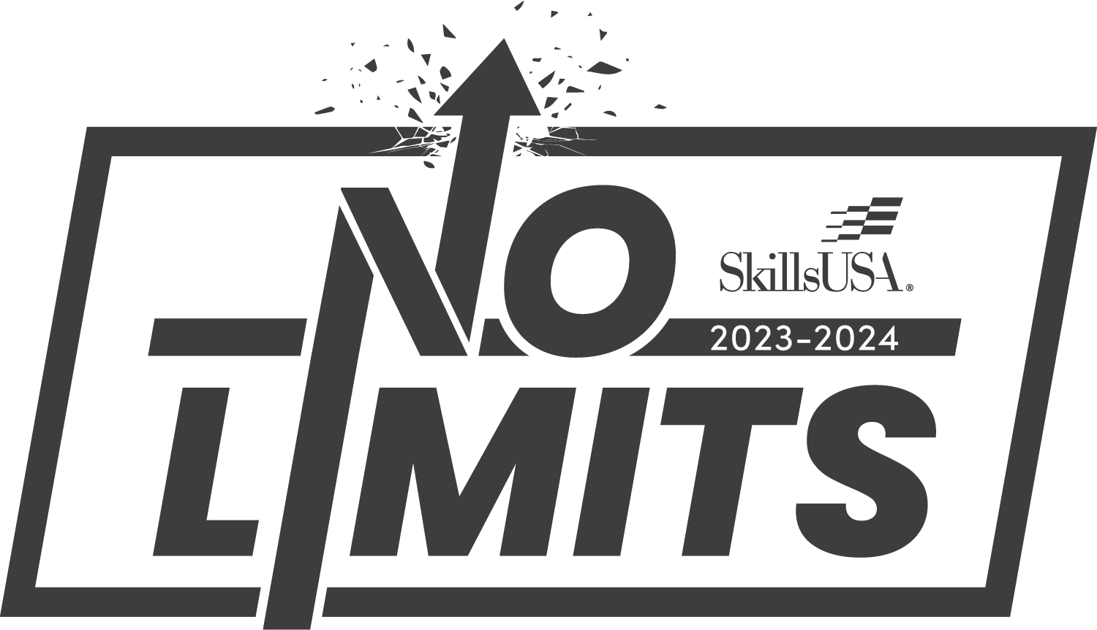

**SKILLSUSA NORTH CAROLINA LEADERSHIP WORKSHOP**

**CHAPTER COMPETITIVE EVENTS**

**LEADERSHIP COMPETITIVE EVENTS.**

- **ALL MEMBERS PARTICIPATE** in only one leadership event (except Quiz Bowl and PSA, members form other contests may assist with this).

- You can only compete in a Leadership contest that ***you have never done*** at the Regional, State or National Level of SkillsUSA. Your event must be **something new to learn**.

- Chapter Leaders have contest rules.

* **Opening Ceremonies:** 7 members. Competition will be Monday evening 8:00pm.
* **Prepared Speech:** 1 member. 2-3 minute presentation. Tuesday Morning.
* **Pledge:**  1 member. Recites the SkillsUSA Pledge. 9-10th grade member. Tuesday Morning
* **Community Service Project:** 2-3 members. 2-3 min. presentation. Tuesday Morning.
* **SkillsUSA Video PSA:** 3-6 members. 30-sec. video PSA. Due Monday 9:30pm.
* **SkillsUSA Creed Audio PSA:**2-3 members.30-sec. audio PSA. Due Monday 9:30pm.
* **SkillsUSA Theme Poster (poster board):** 2-3 members (1 poster). Due Monday 9:30pm.
* **Quiz Bowl:** 3-5 members. (Must compete in another contest also). Tuesday Morning.

**OTHER EVENTS:**

* **Chapter Spirit Points -** based on commitment, dedication, devotion, socialization, etc.

###### All members – points determined by energy and enthusiasm throughout the retreat.

**SKILLS COMPETITIVE EVENTS:**

#### THE GREAT EXPERIENCE – Monday Afternoon

***ALL Members*** participate in the Great Experience.

Medical / Physical Limitations need to be addressed prior to the G.E.

* **KRAZY KRAFT** (Boat Building/Race) immediately preceding the Great Experience

**Goal Setting**

*Goals for the conference & goals for the year*

**What are your goals for the State Leadership Workshop?**

(What do you hope to gain, learn, experience, etc.)

_________________________________________________________________

_________________________________________________________________

_________________________________________________________________

_________________________________________________________________

_________________________________________________________________

**What are your personal goals for this school year?**

_________________________________________________________________

_________________________________________________________________

_________________________________________________________________

_________________________________________________________________

_________________________________________________________________

**What are your goals for your SkillsUSA Chapter this year?**

_________________________________________________________________

_________________________________________________________________

_________________________________________________________________

_________________________________________________________________

_________________________________________________________________

**SKILLSUSA FRAMEWORK ACTIVITY**

|  |  |  |
| --- | --- | --- |
| **Personal Skills** | **Workplace Skills** | **Technical Skills** |
|  |  |  |
|  |  |  |
|  |  |  |
|  |  |  |
|  |  |  |
|  |  |  |

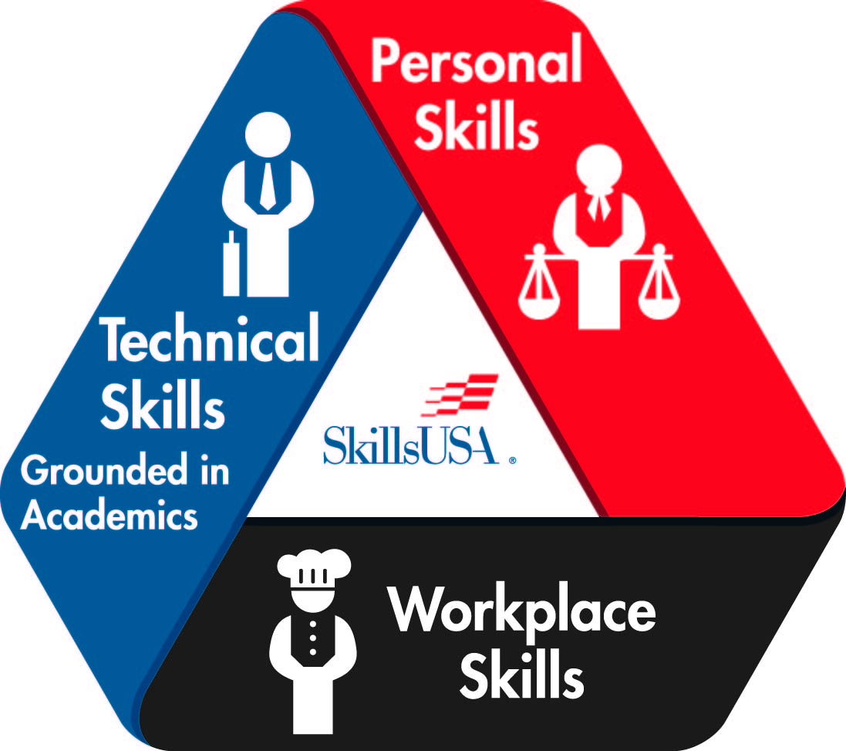

**A Balanced SkillsUSA Program of Work**

Why should your chapter create a yearly SkillsUSA Program of Work (PoW)? When a chapter provides rich experiences in all six categories of the PoW, it empowers students to become career ready. These activities allow students the opportunity to practice and perform the Essential Elements of the SkillsUSA Framework and receive feedback to strengthen their skills.

Each program of work category has activities for the committee to facilitate for the entire chapter. Program of work committees each contribute to the ultimate success of the chapter and the educational experiences provided to members.

**Advocacy & Marketing** – Promote SkillsUSA chapter programs and career and technical education programs, public relations initiatives and experiences to build social responsibility.

Participation in the Advocacy & Marketing category creates a career-ready student that is able to:

* Identify characteristics of effective marketing.
* Promote your organization.
* Advocate for self and your ideas.

Activities conducted in the category of Advocacy and Marketing might include:

* _____________________________________________________
* _____________________________________________________
* _____________________________________________________
* _____________________________________________________

**Community Engagement** – Assess community needs, identify services and employ skills to meet needs that develop long-lasting partnerships.

Participation in the Community Engagement category creates a career-ready student that is able to:

* Assess and analyze needs.
* Create a heart of service.
* Apply technical skills for the benefit of others.

Activities in the category of Community Engagement might include:

* _______________________________________________________________
* _______________________________________________________________
* _______________________________________________________________
* _______________________________________________________________

**Financial Management** – Develop personal financial literacy and entrepreneurship skills through relevant work experience, project management and chapter fundraising.

Participation in the Financial Management category creates a career-ready student that is able to:

* Work efficiently and effectively within a budget.
* Effectively manage personal finances.
* Manage resources efficiently.

Activities in the category of Financial Management might include:

* _______________________________________________________________
* _______________________________________________________________
* _______________________________________________________________
* _______________________________________________________________

*PROGRAM OF WORK (continued)*

**Leadership Development** – Establish interpersonal relationships, individual and team development through chapter operations, leadership competitions and individualized growth plans.

Participation in the Leadership Development category creates a career-ready student that is able to:

* Communicate vision.
* Inspire others to action to reach a common goal.
* Equip and empower team members.
* Develop interpersonal skills.

Activities in the category of Leadership Development might include:

* _______________________________________________________________
* _______________________________________________________________
* _______________________________________________________________
* _______________________________________________________________

**Partner & Alumni Engagement** – Engage former members, parents, advisory committees, administrators, faculty and business and industry partners in SkillsUSA chapter and classroom activities.

Participation in the Alumni and Partner Engagement category creates a career-ready student that is able to:

* Appreciate the contributions of others.
* Build a personal and professional network.
* Recognize and value the expertise of others.

Activities in the category of Partner and Alumni Engagement might include:

* _______________________________________________________________
* _______________________________________________________________
* _______________________________________________________________
* _______________________________________________________________

**Workplace Experiences** –Participation in career exploration, planning and work-based learning opportunities including the SkillsUSA Championships.

Participation in the Workplace Experiences category creates a career-ready student that is able to:

* Gain relevant work experience.
* Develop job seeking skills.
* Understand workplace expectations.

Activities in the category of Workplace Experiences might include:

* _______________________________________________________________
* _______________________________________________________________
* _______________________________________________________________
* _______________________________________________________________

**CHAPTER EXCELLENCE PROGRAM Level 1**

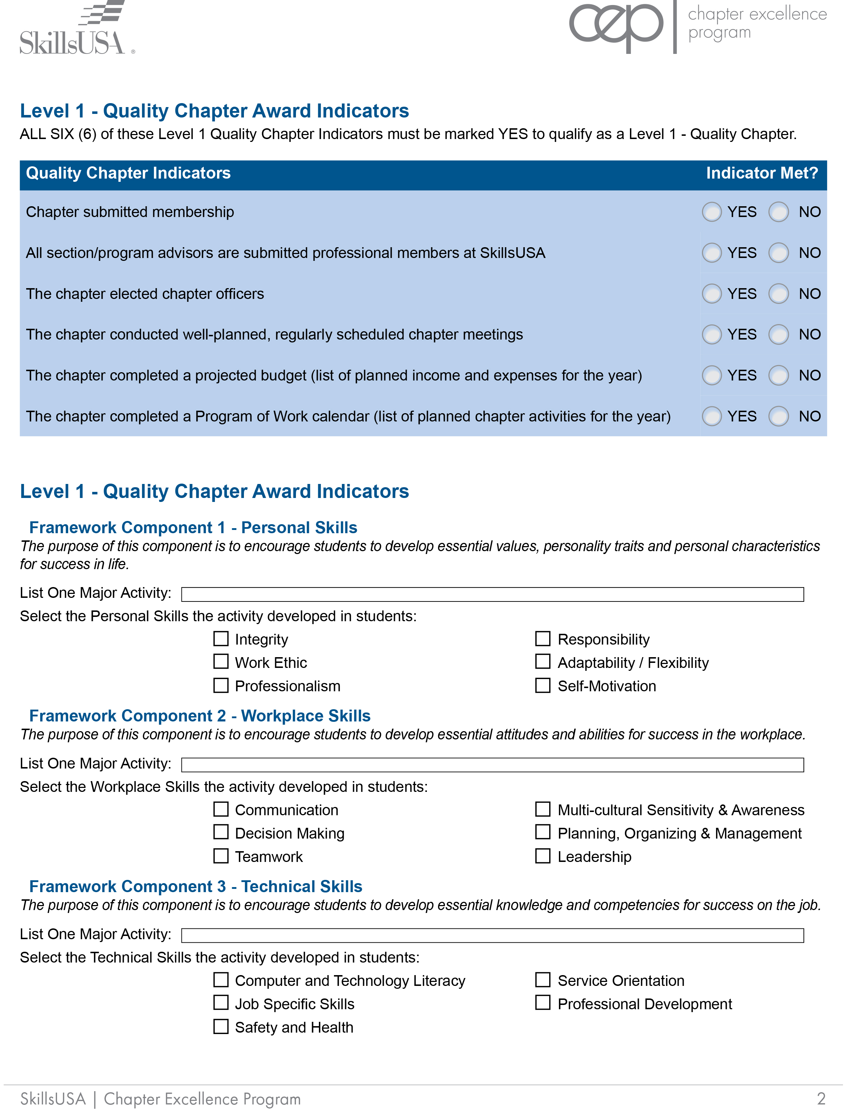

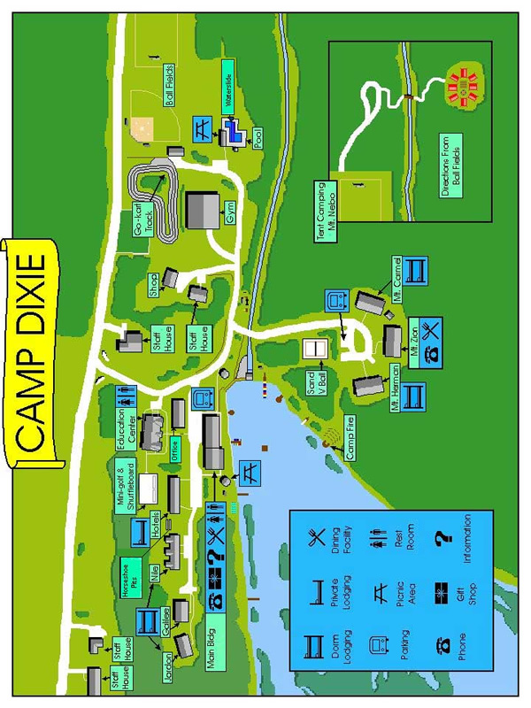

**FRAMEWORK STORY**

**NOTES**

**SkillsUSA NORTH CAROLINA STATE LEADER AWARD**

**NAME­­­ ________________________________________ CHAPTER _________________**

**SCHOOL ______________________________________ REGION __________________**

1. **PURPOSE**- The primary purpose of the State SkillsUSA Leader Award is to provide the participant an opportunity to increase their knowledge pertaining to the SkillsUSA organization and general leadership attributes. A second purpose of the award is to help an officer in being a more active member in the SkillsUSA organization.
2. **PROCEDURE**- The SkillsUSA North Carolina State Officers and Camp Council Members will be available to verify and certify that the participant has satisfied a particular requirement of the State Leader Award. Each state officer or camp council member may verify and sign off on NO MORE THAN 5 ITEMS. **All requirements must be satisfied and the completed form turned into your Chapter/Section Leader by Monday night 10:00pm.**
3. **REQUIREMENTS-**

_____ 1. In what year was VICA (SkillsUSA’s original name) founded?

_____ 2. Demonstrate knowledge of the SkillsUSA Motto.

_____ 3. Demonstrate knowledge of the SkillsUSA Colors.

_____ 4. Demonstrate knowledge of the SkillsUSA Creed.

_____ 5. Demonstrate knowledge of the SkillsUSA Official Dress.

_____ 6. Demonstrate knowledge of the SkillsUSA Emblem.

_____ 7. Demonstrate knowledge of the SkillsUSA Pledge.

_____ 8. Know a part/section in the Opening Ceremony.

_____ 9. Demonstrate knowledge of the duties of SkillsUSA Officers.

_____ 10. Know the National SkillsUSA Theme for this Year.

_____ 11. Name the 3 components and 2 essential elements of each of the SkillsUSA Framework.

_____ 12. Identify what CEP stands for and how many activities must be completed for Level 1.

_____ 13. Identify the 6 areas of the Program of Work and show your fill in chart in this program.

_____ 14. Discuss a membership recruitment activity you might implement at your school.

_____ 15. Explain the duties and benefits of serving as a SkillsUSA State Officer.

_____ 16. Name the SkillsUSA North Carolina State Officers.

_____ 17. Name the SkillsUSA North Carolina Executive Director.

_____ 18. Name the National SkillsUSA Executive Director.

_____ 19. State when and where the SkillsUSA North Carolina State Conference will be held.

_____ 20. State when and where the SkillsUSA National Conference will be held.

_____ 21. Name the Governor of North Carolina.

_____ 22. Name the two U.S. Senators from North Carolina.

_____ 23. Name the three branches of the Federal Government and discuss the purpose of each one.

_____ 24. Attend the Regional Planning Meeting. *(*Regional Rally advisor to sign off on this)*

_____ 25. Deliver your Framework Story.

_____ 26. Attend both flag raisings in the morning.