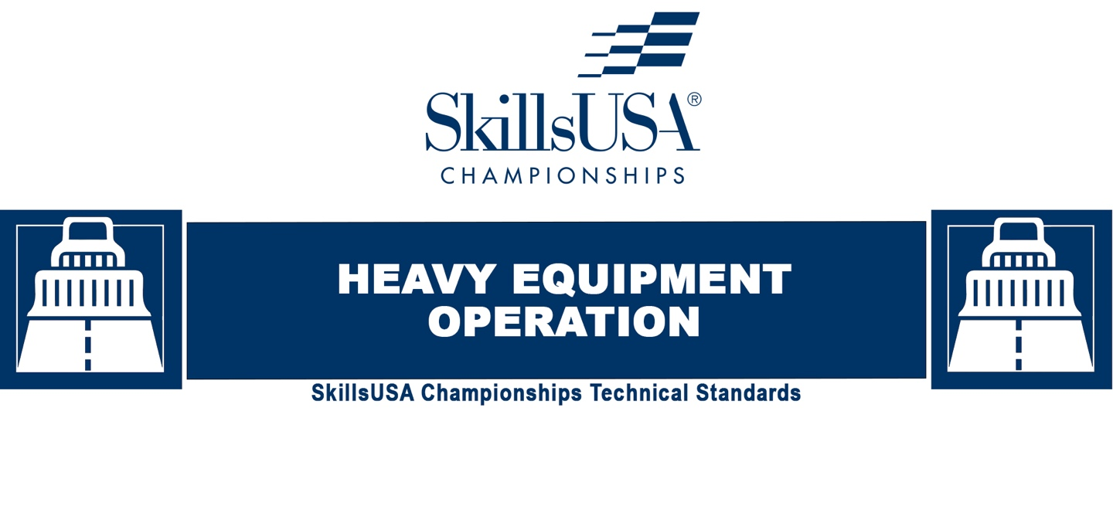
2023-24
Purpose
To evaluate each competitor’s preparation for employment and to recognize outstanding students for excellence and professionalism in the field of heavy equipment operation.

First, download and review the General Regulations at: http://updates.skillsusa.org.

Eligibility
Open to active SkillsUSA members enrolled in programs with heavy equipment operation and maintenance as an occupational objective.

Competitors must have completed a minimum of one full semester or equivalent experience of curriculum, including in-seat operation of heavy equipment. (For eligibility purposes, training simulators do not qualify as “heavy equipment operation.”)

Clothing Requirements
Class D: Competition Specific — Blue Attire
Official SkillsUSA light blue work shirt
Navy pants
Black, brown or tan work safety shoes (with protective toe cap that cover the ankles)

Note: Safety glasses must have side shields or goggles. (Prescription glasses may be used only if they are equipped with side shields. If not, they must be covered with goggles.)

Note: Orientation: competitors must wear their official competition specific blue attire to the orientation meeting. Competition days: attire on the days scheduled for heavy equipment operation will include competitor-provided navy pants, eye protection, safety toe/protective toe cap footwear that cover the ankles, and optional industry-standard high visibility rain gear or similar outerwear (if applicable). The technical committee will provide each competitor an industry-standard, high-visibility T-shirt/vest, hard hat, and if applicable, gloves.

These regulations refer to clothing items that are pictured and described at: www.skillsusastore.org. If you have questions about clothing or other logo items, call 1-888-501-2183.

Safety Instruction and Verification of Training
Important: Both the instructor and the competitor certify that by registering for this competition, the competitor has received instruction in heavy equipment operation and has demonstrated knowledge of the operation, basic machine and maintenance components, and safe usage of the following — but not limited to — equipment and machines:

- Surveying Equipment and Grade Control Systems
- Excavators
- Wheel Loaders
- Haulage Systems (trucks)
- Skid Steers
- Compact Track Loaders
- Bulldozers
- Compaction Equipment

Both the instructor and competitor also certify that SkillsUSA Inc., the national technical committee and national judges are released from all responsibilities relating to personal injury resulting from their use. Competitors will be removed from competition if proper training has not been provided and/or they are using the equipment in an unsafe manner.

Equipment and Materials
- Supplied by the technical committee:
  - All materials, tools and equipment needed for the competition.
  - Industry-appropriate uniform for competition days including high visibility T-shirt/vest, hard hat and gloves (if required).
- Supplied by the competitor:
  - Eye protection
  - Safety footwear as described under the Clothing Requirements section
  - Optional rain/outerwear for outdoor competition.
  - All competitors must create a one-page resume and submit to the Skills portal by the due date. See “Resume Requirement” below for guidelines

Resume Requirement
Competitors must create a one-page resume to submit online. SkillsUSA national competitors should submit their resume by the deadline published on the competition updates page of our website. The deadline and link for resume submission will be published on http://updates.skillsusa.org. Failure to submit a resume will result in a 10-point penalty.

Your resume must be saved as a PDF file type using file name format of “Last Name_First Name.” For example, “Amanda Smith” would save her resume as Smith_Amanda. If you need assistance with saving your file as a PDF, visit the Adobe website for more information.

Note: Check the Competition Guidelines and/or the updates page on the SkillsUSA website at http://updates.skillsusa.org.

Prohibited Devices
Cellphones, electronic watches and/or other electronic devices not approved by a competition’s national technical committee are NOT allowed in the competition area. Please follow the guidelines in each technical standard for approved exceptions. Technical committee members may also approve exceptions onsite during the SkillsUSA Championships if deemed appropriate.

Penalties for Prohibited Devices
If a competitor’s electronic device makes noise or if the competitor is seen using it at any time during the competition, an official report will be documented for review by the Director of the SkillsUSA Championships. If confirmed that the competitor used the device in a manner which compromised the integrity of the competition, the competitor’s scores may be removed.

Scope of the Competition
The competition is defined by industry standards as identified by SkillsUSA technical committee, which includes Volvo Construction Equipment, Caterpillar Inc., Komatsu, and John Deere Construction and Forestry.

Knowledge Performance
The competition will include a written knowledge exam to assess knowledge of principles, theories, and procedures used in heavy equipment operation. Competitors are required to take the SkillsUSA Professional Development Test.

Skills Performance
The competition will include a series of stations where students will operate or inspect construction and surveying equipment, complete a written knowledge test, and participate in an interview.

Competition Guidelines
- Competitors may be assigned problems or projects requiring as little as 10 minutes to perform or as long as four (4) hours.
- The following general safety rules will be followed:
  - Seat belt must be worn at all times during operation of equipment.
  - No loose clothing is permitted.
  - Long hair must be tied behind the head or netted.
  - Gloves must not be worn during operation of machinery unless competition requires.
  - Any liquid or grease spilled must be cleaned up immediately and reported to the judge.
  - All injuries, no matter how slight, must be reported immediately to the judge.
- In addition, competitors will be judged on safety, operation performance and a written test. Points allowed will be assigned by the technical committee based on the difficulty of the assigned task.

Standards and Competencies
HEO 1.0 — Demonstrate competencies related to safety
- Demonstrate knowledge of OSHA, MSHA, NIOSH requirements
- Present understanding of personal protection and basic principles of safety
- Understand and practice safe equipment operation and maintenance

HEO 2.0 — Demonstrate competencies related to machine component identification
- Identifies and describes the common
- uses, types, components, instruments, parts, controls and attachments on all machines listed in this document
- Demonstrates comprehension of prestart inspection procedures
- Demonstrates comprehension of preventative maintenance requirements
- Demonstrates use of hand signals

HEO 3.0 — Demonstrate competencies related to grades
- Demonstrates comprehension of preparing graded surfaces using heavy equipment
- Identification of construction stakes and interpretation of marks on each type of stake
- Demonstrates comprehension in grading slopes
- Discusses how soil conditions affect equipment performance and explains techniques for working with various types of soils
- Understands basic math skills required for site. Including methods and practice in calculating the areas and volumes of various geometric shapes, as well as formulas and methods used to calculate cut and fill requirements on a job.
- Demonstrates comprehension of reading and interpreting site plans

HEO 4.0 — Demonstrate competencies related to excavators
- Identifies and describes the common types, uses, and components and parts of excavators
- Demonstrates comprehension of safety guidelines, prestart inspection procedures, and preventive maintenance requirements
- Performs startup and operation, and demonstrates work activities and maneuvers associated with an excavator
- Uses Excavator to complete assigned task
- Demonstrates understanding of planning and executing earthmoving activities on various types of construction projects

HEO 5.0 — Demonstrate competencies related to wheel loaders
- Identifies and describes the common types, uses and components and parts of wheel/track loaders
- Demonstrates comprehension of safety guidelines, prestart inspection procedures, and preventive maintenance requirements
- Performs startup and operation, and demonstrates work activities and maneuvers associated with a wheel/track loader
- Uses wheel/track loader to complete assigned task

HEO 6.0 — Demonstrate competencies related to haulage systems
- Identifies and describes the common types, uses and components and parts of haulage systems
- Demonstrates comprehension of safety guidelines, prestart inspection procedures, and preventive maintenance requirements
- Performs startup and operation, and demonstrates work activities and maneuvers associated with a haulage systems
- Uses Hauler to complete assigned task
- Demonstrates understanding of loading and dumping procedures on and off road

HEO 7.0 — Demonstrate competencies related to bulldozers
- Identifies and describes the common types, uses, and components and parts of bulldozers
- Demonstrates comprehension of safety guidelines, prestart inspection procedures and preventive maintenance requirements
- Performs startup and operation, and demonstrates work activities and maneuvers associated with bulldozers
- Uses dozer to complete assigned task

HEO 8.0 — Demonstrate competencies related to compaction equipment
- Identifies and describes the common types of compaction equipment; the primary instruments, controls, and attachments of a roller
- Performs startup and operation, and demonstrates work activities and maneuvers associated with a compactor
- Uses compactor to complete assigned task

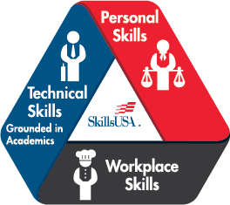
HEO 9.0 — SkillsUSA Framework
The SkillsUSA Framework is used to pinpoint the Essential Elements found in Personal Skills, Workplace Skills and Technical Skills Grounded in Academics. Students will be expected to display or explain how they used some of these Essential Elements. Please reference the graphic, as you may be scored on specific elements applied to your project. For more, visit: www.skillsusa.org/who-we-are/skillsusa-framework/.

Committee Identified Academic Skills
The technical committee has identified that the following academic skills are embedded in this competition.

Math Skills
Use fractions to solve practical problems.
Use proportions and ratios to solve practical problems.
Simplify numerical expressions.
Solve practical problems involving percents.
Solve single variable algebraic expressions.
Measure grade.
Make predictions using knowledge of probability.
Make comparisons, predictions and inferences using graphs and charts.
Organize and describe data using matrixes.
Use laws of exponents to perform operations.
Solve practical problems involving complementary, supplementary and congruent angles.
Solve problems involving symmetry and transformation.

Science Skills
Use knowledge of physical properties (shape, density, solubility, odor).

Language Arts Skills
Provide information in conversations and in group discussions.
Provide information in oral presentations.
Demonstrate use of such verbal communication skills as word choice, pitch, feeling, tone and voice.
Demonstrate use of such nonverbal communication skills as eye contact, posture and gestures using interviewing techniques to gain information.
Analyze mass media messages.
Demonstrate comprehension of a variety of informational texts.
Use text structures to aid comprehension.
Understand source, viewpoint and purpose of texts.
Organize and synthesize information for use in written and oral presentations.
Demonstrate knowledge of appropriate reference materials.
Use print, electronic databases and online resources to access information in books and articles.
Demonstrate narrative writing.
Demonstrate expository writing.
Demonstrate persuasive writing.
Demonstrate informational writing.
Edit writing for correct grammar, capitalization, punctuation, spelling, sentence structure and paragraphing.

Connections to National Standards
State-level academic curriculum specialists identified the following connections to national academic standards.

Math Standards
Numbers and operations
Algebra
Geometry
Measurement
Data analysis and probability
Problem solving
Reasoning and proof
Communication
Connections
Representation

Source: NCTM Principles and Standards for School Mathematics. For more information, visit: http://www.nctm.org.

Science Standards
Understands the structure and properties of matter.
Understands the sources and properties of energy.
Understands forces and motion.
Understands the nature of scientific inquiry.
Understands the scientific enterprise.

Source: McREL compendium of national science standards. To view and search the compendium, visit: http://www2.mcrel.org/compendium/.

Language Arts Standards
Students read a wide range of print and nonprint texts to build an understanding of texts, of themselves and of the cultures of the United States and the world; to acquire new information; to respond to the needs and demands of society and the workplace.
Students apply a wide range of strategies to comprehend, interpret, evaluate and appreciate texts. They draw on their prior experience, their interactions with other readers and writers, their knowledge of word meaning and of other texts, their word identification strategies and their understanding of textual features (e.g., sound-letter correspondence, sentence structure, context, graphics).
Students adjust their use of spoken, written and visual language (e.g., conventions, style, vocabulary) to communicate effectively with a variety of audiences and for different purposes.
Students employ a wide range of strategies as they write and use different writing process elements appropriately to communicate with different audiences for a variety of purposes.
Students use a variety of technological and information resources (e.g., libraries, databases, computer networks, video) to gather and synthesize information and to create and communicate knowledge.
Students use spoken, written and visual language to accomplish their own purposes (e.g., for learning, enjoyment, persuasion and the exchange of information).

Source: IRA/NCTE Standards for the English Language Arts. To view the standards, visit: www.ncte.org/standards.

