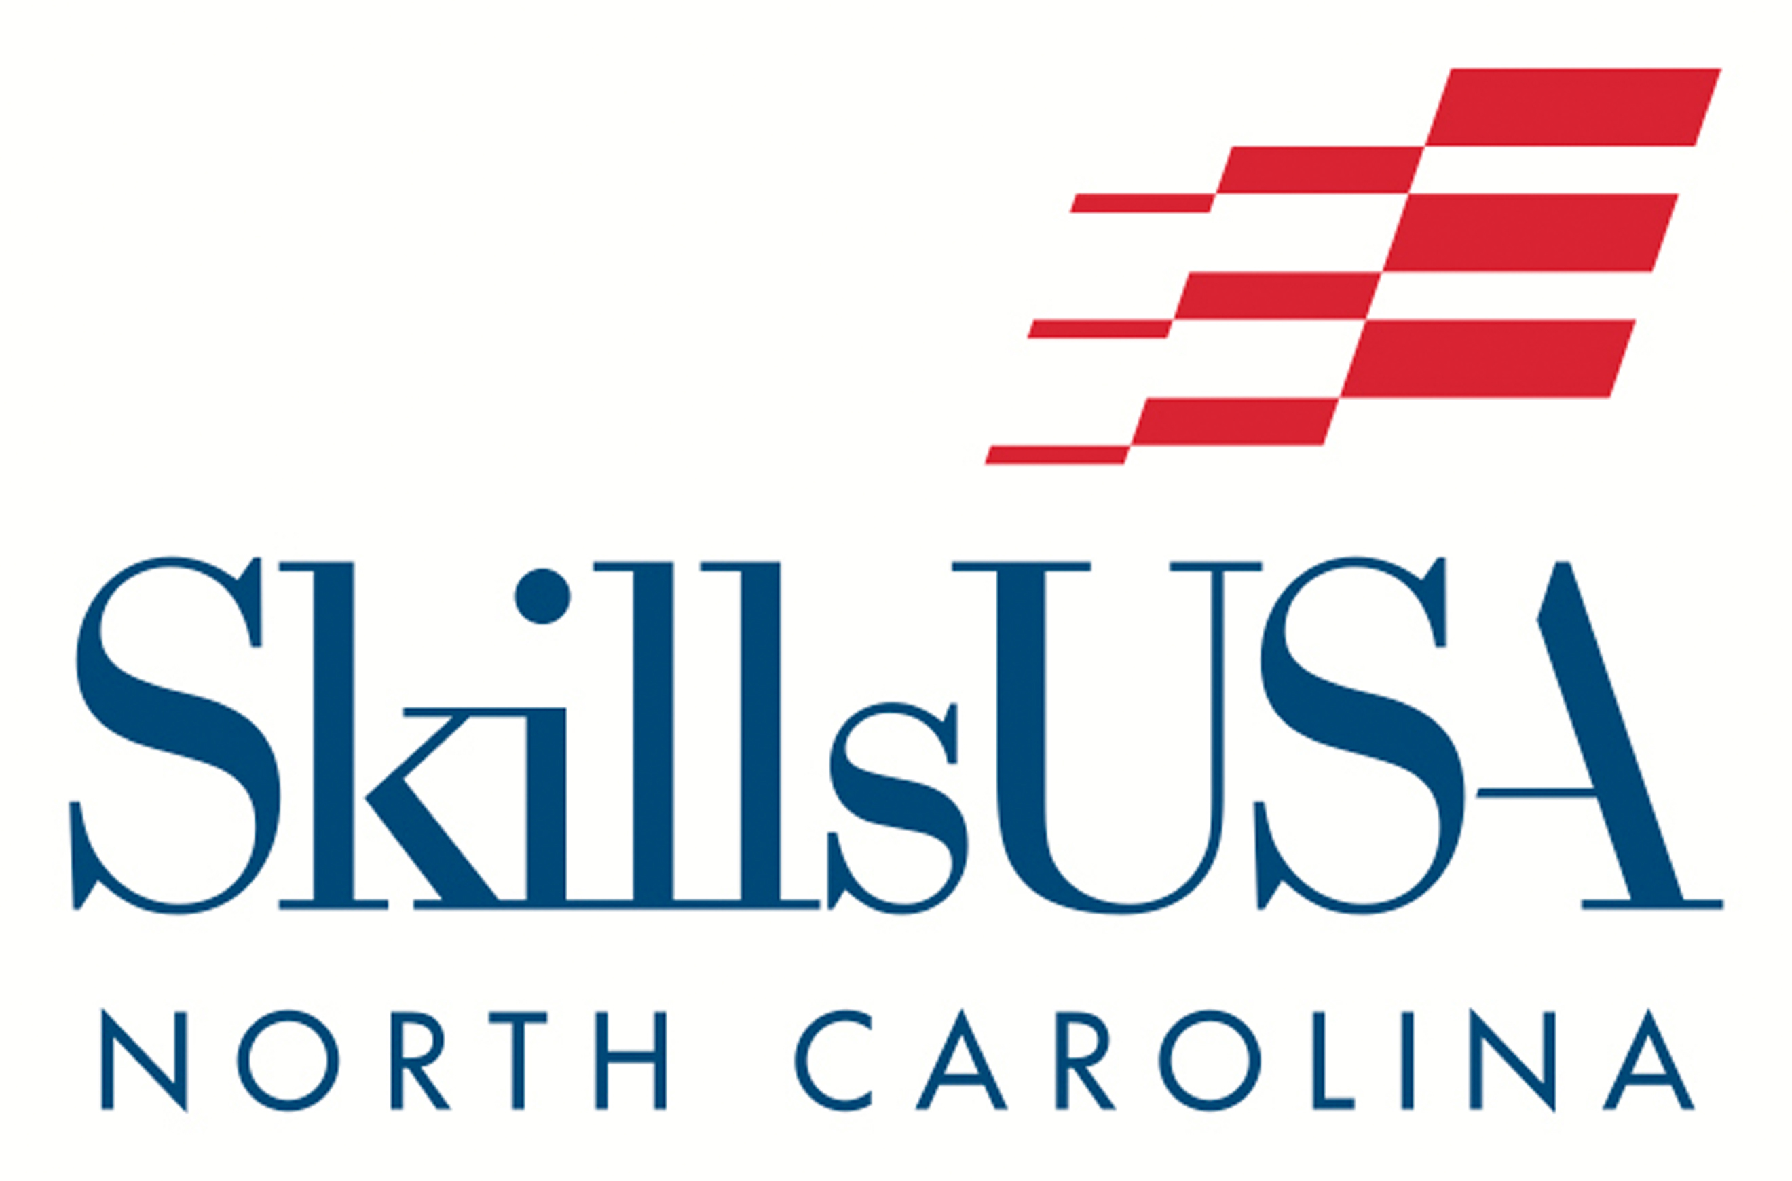
State Conference T-Shirt Design Challenge

Do you have a flair for design? Are you creative? Are you good with design software? Then here is a challenge for you!

SkillsUSA North Carolina is looking for T-Shirt design submissions for our State Conference T-Shirt! These t-shirts are given out to all registered participants at our SkillsUSA North Carolina State Conference. *NOTE: This is NOT the official T-Shirt Design Contest from SkillsUSA that qualifies for national competition.

DESIGN GUIDELINES
- All design entries must be –
- 1 color (solid)
- No shading or blending

- The following text must appear on the T-shirt design:
- “SkillsUSA North Carolina”. (SkillsUSA is ONE word, not 2 words!)
- “State Conference”
- The conference year

- The official SkillsUSA emblem or SkillsUSA logo may NOT appear in the design.

- At the creator’s discretion, the shirt design may incorporate/include:
- SkillsUSA trade/program areas;
- The current annual SkillsUSA theme;
- Attributes or qualities of the state of North Carolina.

- All artwork should be your original creation.

- Designs should be created in a design software such as Illustrator, Photoshop, InDesign, Canva, etc. The artwork should be a comprehensive design that is essentially “camera ready”. SkillsUSA reserves the right to make or request minor changes, as needed, for printing purposes.

SUBMISSION GUIDELINES
- Submit your design file in PDF or JPG format for easy viewing and judging/selection. **Remember to keep your original raw/uncompressed design file, as changes might be requested for final design outcome.

- Design submissions should be emailed to CONTESTS@SkillsUSAnc.org

- Submission Deadline is October 31.

